**GUNADARMA UNIVERSITY**

**FACULTY OF INDUSTRIAL TECHNOLOGY**



**COMPARISON OF DOCKER VIRTUALIZATION TECHNOLOGY IMPLEMENTATION IN MOODLE WITH MARIADB DATABASE CLUSTERED WITH GALERA CLUSTER WITH VIRTUAL MACHINE TECHNOLOGY**

Written By :

Name : Rifqy Adli Damhuri

Student ID Number : 55417203

Department : Informatics Engineering

Advisor : Dr. SURYARINI WIDODO, S.Kom., M.M.S.I.

Submitted in Partial Fulfillment of Requirements

for Bachelor’s Degree

**JAKARTA**

**2021**

**ORIGINALITY STATEMENT AND PUBLICATIONS**

I, the undersigned below,

Name : Rifqy Adli Damhuri

Student Id : 55417203

Departement : Informatics Engineering

Faculty : Industrial Technology

Title : Comparasion of Docker Virtualization Technology Implementation In Moodle with MariaDB Database Clustered With Galera Cluster With Virtual Machine Technology

Session Date :

Passed Date :

To declare that this paper is my own work and can be fully published by Gunadarma University. All quotes in any form have followed the rules, applicable ethics. Regarding the content and writing is the responsibility of the author, not Gunadarma University.

Thus this statement is made truthfully and with full awareness.

Jakarta, February,17th, 2021

(Rifqy Adli Damhuri)

**VALIDATION PAGE**

**ADVISOR COMMITTEE**

| **NO** | **NAME** | **POSITION** |
| --- | --- | --- |
| 1. | Dr. SURYARINI WIDODO, S.Kom., M.M.S.I. | Chairman |
| 2. |  | Member |
| 3. |  | Member |
|  | Session Date : | Tgl/bln/thn* |

**BOARD OF EXAMINERS**

| **NO** | **NAME** | **POSITION** |
| --- | --- | --- |
| 1. | Dr. Ravi Ahmad Salim | Chairman |
| 2. | Prof. Dr. Wahyudi Priyono | Secretary |
| 3. | Dr. SURYARINI WIDODO, S.Kom., M.M.S.I. | Member |
| 4. |  | Member |
| 5. |  | Member |
|  | Passing Date : | Tgl/bln/thn* |

**Acknowledged by,**

| **Advisor** |  | **Head of Bachelor’s Defense**  **Examination Departement** |
| --- | --- | --- |
| **(Dr. SURYARINI WIDODO, S.Kom., M.M.S.I.)** |  | **( Dr. Edi Sukirman, SSi., MM. )** |

# **ABSTRAK**

Rifqy Adli Damhuri, 55417203.

COMPARISON OF DOCKER VIRTUALIZATION TECHNOLOGY IMPLEMENTATION IN MOODLE WITH MARIADB DATABASE CLUSTERED WITH GALERA CLUSTER WITH VIRTUAL MACHINE TECHNOLOGY.

**Skripsi, Jurusan Teknik Informatika, Fakultas Teknologi Industri, Universitas Gunadarma, 2021**

**Kata Kunci : Docker , Galera Cluster, Moodle, Virtual Machine, Teknologi Virtualisasi.**

**xii + 105 + Attachment**

The COVID-19 virus in Indonesia currently impacts all levels of society. The government made several policies to stop the spread of this virus. The Indonesian Ministry of Education, established a new form of learning, namely the distance learning system (PJJ) which is carried out online. The PJJ system causes scenario changes in the application of the learning process. The use of LMS (Learning Management System) has become very popular in education. For the implementation of the Moodle LMS, a device that can act as a server is needed to receive requests from clients (users). In the implementation of using an LMS, one server can receive a lot of requests. Servers that receive too many requests will experience a decrease in performance, including the server being slow in returning requests, disconnecting from services that are running. To improve the performance and performance of the LMS and maximize existing resources, the implementation of Docker virtualization technology is carried out on Moodle with a mariadb database clustered with a galera cluster. Implementation of docker on moodle with mariadb databases clustered with galera clusters can be done by installing ubuntu and docker operating systems, pulling docker images for Moodle and MariaDB databases clustered with galera clusters, creating a network to connect Moodle containers and clustered MariaDB databases with galera cluster, create a container for Moodle and the MariaDB database to be clustered with the galera cluster, install Moodle, perform database integration tests on the clustered MariaDB database with the galera cluster, perform performance tests with the HTPperf utility. Servers that use the Docker implementation can return all requests given without overloading, where servers that use virtual machines experience overload in returning requests.

**Bibliography (2015-2020)**

**ACKNOWLEDGEMENT**

Alhamdulillahirabbil 'alamin, Praise the writer to pray to the presence of Allah SWT for the blessings of His grace and guidance as well as prayers and support from various parties so that the author can complete the final project entitled "COMPARISON OF IMPLEMENTATION OF DOCKER VIRTUALIZATION TECHNOLOGY ON MOODLE WITH CLUSTERED MARIADTER DATABASE WITH VIRTUAL MACHINE TECHNOLOGY ".

This final project is structured to complete some of the requirements in achieving a level equivalent to a Bachelor's Degree (S1) in Informatics Engineering at the Faculty of Industrial Technology, Gunadarma University.

On this occasion, the author would like to thank various parties who have provided guidance and encouragement to the author during the process of making this final project. The author's thanks to:

1. Prof. Dr. E.S. Margianti, SE., MM., as Rector of Gunadarma University.
2. Prof. Dr. -Ing. Adang Suhendra, SSi,SKom,MSc., as Dean industrial Technology Faculty of Gunadarma University.
3. Dr. Lintang Yuniar Banowosari, S.Kom., M.Sc., as Head of Informatic Engineering Informatics Departement of Gunadarma University.
4. Drs. Haryanto, MMSI., as Director of Sarjana Magister Program of Gunadarma University.
5. Dr. Edi Sukirman, SSi., MM., as Head of Bachelor’s Defense Examination Departement of Gunadarma University.
6. Dr. Suryarini Widodo, S.Kom., M.M.S.I., as my advisor that spend time, energy, and busyness to provide guidance, direction, and enthusiasm to the author during the process of this final project.
7. **Diana ………………………….**
8. Gunadarma University lecturers, especially the Faculty of Industrial Technology, Department of Informatics, who have provided their knowledge to the author.
9. Both parents, father Dedi Damhuri and Mother Catur Andawati and the two younger siblings of Tifal Aviva Damhuri and Rafli Zaki Damhuri who always provide prayers, support, material and trust to the author to be able to complete this final project.
10. Discord friends who always helped and gave encouragement in the preparation of this final project, Alvin, Ilham, Andre, Bima
11. Lepkom Assistant and Staff friends who have provided prayer, support, and enthusiasm so that the author can complete this final project.
12. 4IA88 friends who gave encouragement to continue learning and enthusiasm to complete this final project.
13. To all parties that the author may not be able to mention one by one and the author can only thank you for your prayers and support.

**Bogor, 12 Februari 2021**

**Author**

**Rifqy Adli Damhuri**

**Table of contents**

Contents

**ABSTRAK** iv

**CHAPTER I** 1

**INTRODUCTION** 1

**1.1** **Background of Study** 1

**1.2** **Formulation of the Problem** 3

**1.3** **Limitation of the Problem** 4

**1.4** **The Aims of Research** 5

**1.5** **Research Methods** 6

**1.6** **Writing systematics** 6

**CHAPTER II** 8

**REFERENCES** 8

**2.1** **Learning Management System** 8

**2.2** **Moodle** 11

**2.3** **Database** 16

**2.4** **Database Clustering** 18

**2.5** **Galera Cluster** 20

**2.6** **Virtualitation Technology** 22

**2.7** **Virtual Machine** 23

**2.8** **Docker** 24

**2.9** **Linux** 27

**2.10** **Ubuntu** 29

**2.11** **Ubuntu 16.04.6 Xenial Xerxus** 29

**2.12** **Httperf** 31

**CHAPTER III** 33

**RESEARCH METHOD** 33

**3.1** **Analysis of the Current System** 33

**3.2** **System Proposal** 34

**3.3** **System Analysis** 36

**3.4** **Research Method** 37

**3.4.1** **Installing Ubuntu Desktop 16.04.6 Xenial Xerxus** 38

**3.4.2** **Docker Engine Instalation** 47

**3.4.3** **Pull Docker Image Moodle** 49

**3.4.4** **Pull Docker Image Database Cluster bitnami/mariadb-galera** 50

**3.4.5** **Creating a Network in Docker** 51

**3.4.6** **Creating a Moodle Container** 52

**3.4.7** **Creating a Container Database (Node1)** 52

**3.4.8** **Creating a Container Database (Node2)** 55

**3.4.9** **Moodle Instalation** 58

**3.4.10** **Test for Database Integration between Nodes** 62

**Chapter IV** 65

**Result and Discussion** 65

**4.1** **Implementation of Infrastructure and Architecture** 65

**4.1.1** **Operating System** 65

**4.1.2** **Docker** 66

**4.1.3** **Docker Network** 66

**4.1.4** **Docker Images** 67

**4.1.5** **Docker Container** 67

**4.1.6** **Httperf** 68

**4.2** **Test Database Integration between Nodes** 69

**4.3** **Docker Test** 70

**4.3.1** **Reply Rate** 80

**4.3.2** **Reply Time** 81

**4.3.3** **CPU Time** 82

**4.3.4** **Client Timeout** 84

**4.4** **Virtual Machine Test** 85

**4.5** **Test Server Performance in terms of CPU Usage** 97

**CHAPTER V** 100

**SUGGESTIONS AND CONCLUSIONS** 100

**5.1** **Conclusion** 100

**5.2** **Suggestion** 102

**BIBLIOGRAPHY** 103

**Program List Attachment** 1

**Output List Attachment** 4

**List of Picture**

Picture 2.1 LMS (Learning Management System) Moodle Logo 11

Picture 2.2 Moodle Interface 15

Picture 2.3 Desktop Ubuntu 16.04.6 Xenial Xerxus Interface 30

Picture 2.4 Httperf Result 32

Picture 3.1 Virtual Machine Architecture 34

Picture 3.2 Docker Architecture 35

Picture 3.3 MariaDB database clustered by galera cluster 36

Picture 3.4 System Development Chart of docker implementation on moodle with

MariaDB database clustered by galera cluster……………………………………… 37

Picture 3.5 Ubuntu Web Interface 38

Picture 3.6 Command Pompt 39

Picture 3.7 Rufus Interface 40

Picture 3.8 BIOS Settings 41

Picture 3.9 Boot Menu 42

Picture 3.10 Ubuntu Installation 43

Picture 3.11 Preparing to install Ubuntu 44

Picture 3.12 Installation Type 44

Picture 3.13 Choosing Time Zone and Location 45

Picture 3.14 Keyboard layout 46

Picture 3.15 Who are you ? 46

Picture 3.16 Ubuntu Installation Process 47

Picture 3.17 Ubuntu Update 48

Picture 3.18 Install Docker Engine 48

Picture 3.19 Docker Version 49

Picture 3.20 Pull Image Moodle Process 49

Picture 3.21 Pull Image bitnami/mariadb-galera Process 50

Picture 3.22 List Docker Images 50

Picture 3.23 Making Network 51

Picture 3.24 List Network 51

Picture 3.25 Creating Container Moodle 52

Picture 3.26 Creating Container Database(Node 1) 53

Picture 3.27 Creating Container Database(Node 2) 55

Picture 3.28 Docker Network Inspect 56

Picture 3.29 Choosing Language 58

Picture 3.30 Choosing Path 59

Picture 3.31 Choosing Database Service 59

Picture 3.32 Database Settings 60

Picture 3.33 Moodle Check the Minimum Requiretments 60

Picture 3.34 Instalasi Moodle Success 61

Picture 3.35 Admin Data Filling 61

Picture 3.36 Dashboard Moodle 62

Picture 3.37 Docker Architecture System 63

Picture 3.38 Command to enter the container and database 63

Picture 3.39 Info displayed by wsrep_cluster_size 64

Picture 4.1 Ubuntu 16.04.6 Xenial Xerxus Interface 66

Picture 4.2 Docker Version 66

Picture 4.3 Docker Network Interface 67

Picture 4.4 Course Moodle Page 68

Picture 4.5 Command to enter container and database 69

Picture 4.6 Output Wsrep_Cluster_Size 70

Picture 4.7 Test docker with HTTPERF with 800 requests and 50 requests/second 71

Picture 4.8 Test docker with HTTPERF with 800 requests and 80 requests/second 72

Picture 4.9 Test docker with HTTPERF with 800 requests and 100 requests/second 73

Picture 4.10 Test docker with HTTPERF with 1000 requests and 50 requests/second 74

Picture 4.11 Test docker with HTTPERF with 1000 requests and 80 requests/second 75

Picture 4.12 Test docker with HTTPERF with 1000 requests and 100 requests/second 76

Picture 4.13 Test docker with HTTPERF with 1200 requests and 50 requests/second 77

Picture 4.14 Test docker with HTTPERF with 1200 requests and 80 requests/second 78

Picture 4.15 Test docker with HTTPERF with 1200 requests and 100 requests/second 79

Picture 4.16 Test VM with HTTPERF with 800 requests and 50 requests/second 86

Picture 4.17 Test VM with HTTPERF with 800 requests and 80 requests/second 87

Picture 4.18 Test VM with HTTPERF with 800 requests and 100 requests/second 88

Picture 4.19 Test VM with HTTPERF with 1000 requests and 50 requests/second 89

Picture 4.20 Test VM with HTTPERF with 1000 requests and 80 requests/second 90

Picture 4.21 Test VM with HTTPERF with 1000 requests and 100 requests/second 91

Picture 4.22 Test VM with HTTPERF with 1200 requests and 50 requests/second 92

Picture 4.23 Test VM with HTTPERF with 1200 requests and 80 requests/second 93

Picture 4.24 Test VM with HTTPERF with 1200 requests and 100 requests/second 94

Picture 4.25 CPU Usage on moodle container 97

Picture 4.26 CPU Usage on database container 97

Picture 4.27 CPU Usage on Virtual Box that using Running Moodle VM 98

List of Tables

Table 3.1 Hardware Spesification 36

Table 3.2 Software Spesification 37

Table 4.1 Docker Test 79

Table 4.2 Reply Rate Test Result 80

Table 4.3 Reply Time Test Result 81

Table 4.4 CPU Time Test Result 83

Table 4.5 Client Time Test Result 85

Table 4.6 Docker and Vritual Machine 94

Table 4.7 Comparison of Docker and Virtual Machine in terms of CPU Usage 98

# **CHAPTER I**

# **INTRODUCTION**

1. **Background of Study**

The COVID-19 virus in Indonesia currently impacts all levels of society. With the COVID-19 virus pandemic, the government has made several policies to stop the spread of this virus, such as conducting lockdowns in areas that are already included in the red zone for the spread of the Covid-19 virus, or physical distancing to avoid the virus by physical contact. The Government of the Republic of Indonesia has also established various health protocols. This protocol is implemented throughout Indonesia by the government, guided centrally by the Indonesian Ministry of Health. With the new provisions for activities implemented by the Indonesian government during the COVID-19 pandemic, this also affects the world of education in Indonesia. The Indonesian Education Minister, Nadiem Anwar Makarim, B.A., M.B.A, established a new form of learning, namely the distance learning system or often called (PJJ) which is carried out online.

The Distance Learning System causes scenario changes in the application of the learning process. The use of LMS (Learning Management System) has become very popular in the world of education, especially in universities. LMS is a software that can help plan and implement a learning process. The most popular LMS used today is Moodle. Moodle is an LMS that makes it possible to create powerful, flexible, and engaging Distance Learning experiences. Moodle has features that make it easier for lecturers and students to manage courses and materials. Lecturers can easily manage access rights, teaching materials and value management at Moodle. Moodle also has many features that make it very easy for students to do distance learning (idcloudhost, 2019).

For the implementation of the Moodle LMS, a device that can act as a server is needed to receive requests from clients (users). In a university that has thousands of students using LMS, one server can receive very many requests. Servers that receive too many requests will experience a decrease in performance, including the server being slow in returning requests, disconnecting from the service being run, even on some types of servers it can cause a critical message in the form of a warning on the server informing that a problem occurred with the server when receiving request. The problems that usually occur above cause the services provided by the server to be temporarily inaccessible, thus disrupting the distance learning process. One way to overcome this is by adding server resources which will cost money. To save costs and also improve server performance, virtualization technology is very important.

Virtualization technology is a technology that allows a virtual form of something that is physical, for example, an operating system. The mechanism of virtualization technology makes hardware resources such as processors, memory, storage, and network devices used simultaneously. Several types of virtualization technologies include virtual machines and dockers.

Virtual Machine is a virtualization technology that works with the same functions as a physical computer with all the complete building components, such as the operating system. Virtual machines are usually used to test the operating system, as well as applications before installing them on the host or main computer. Virtual machines are fully virtualized, which means virtual machines virtualize the operating system and all the default software from the operating system, therefore the use of virtual machines is recommended for devices that have high enough specifications to support good virtualization performance (virtualiable, 2020).

Docker is a virtualization technology based on the Linux-64-bit operating system. Docker does not fully virtualize, which means Docker does virtualization on top of the kernel that runs on the operating system below (Rizqiwati, Suryanto, & Syaifuddin, 2018). When the operating system used in the host machine is linux, the docker virtualization runs on that operating system and does not require another operating system like the virtual machine, so that Docker only uses very small memory resources and can run quickly. Docker settings data and supporting files are referred to as images. Furthermore, the image collection is combined in one container called container.

To improve the performance of the LMS and maximize existing resources, system development is carried out using Docker on Moodle and the database that clustered with galera cluster. The database used is the MariaDB database which is clustered with galera cluster. According to Piere (in Fiandrianto, 2015) Galera cluster is an open source software developed by Codership which functions to convert an ordinary database into a syncronus multimaster cluster. Syncronus multimaster cluster itself is a database replication technique that allows the database to store data on a group of computers and be updated by each group. In a galera cluster these groups are called nodes. The advantage of a galera cluster is to implement a syncronus multimaster cluster. Each data uses syncronus mode to replicate between cluster members, this method is used to ensure that no data is lost when the database crashes at one node. Another advantage of the galera cluster is also seen in the consistency of data across all database nodes. There is no lagging when inserting data so it can be ensure that the data is consistent across all cluster member servers.

* 1. **Formulation of the Problem**

Based on the background that has been discussed, the problem formulation of this study is :

1. How to implement Docker on moodle with MariaDB database clustered with galera cluster compared to virtual machine virtualization technology.
2. How are the results of the implementation of Docker on moodle with MariaDB database clustered by galera clusters, measured by the amount of time it takes the CPU to process an instruction (CPU time) compared to virtual machine virtualization technology.
3. What are the results of implementing Docker on Moodle with the MariaDB database clustered by galera clusters, measured by the average number of requests returned per second (reply rate) compared to virtual machine virtualization technology.
4. How are the results of implementing Docker on moodle with MariaDB database clustered with galera clusters, measured by the average time when requests are returned by the server (reply time) compared to virtual machine virtualization technology.
5. How are the results of implementing Docker on Moodle with the MariaDB database clustered by galera clusters, measured by the number of services experiencing timeouts on the client side (client timeout) compared to virtual machine virtualization technologys.
6. How is the CPU and memory usage on the server when using Docker virtualization technology and when using virtual machine virtualization technology.
   1. **Limitation of the Problem**

This writing is limited to the creation and implementation of a docker on the Moodle LMS with the MariaDB database which is clustered with a galera cluster. Research is limited to :

1. Using two database nodes which are clustered using the Galera Cluster.
2. Using a server with AMD Ryzen 5 3400G Processor specifications, 8GB RAM, and AMD Radeon (TM) RX Vega 11 Graphics GPU which acts as a server for Moodle and two database nodes.
3. Analyze CPU time, reply rate, reply time, and client timeout on the docker implementation on Moodle with a clustered MariaDB database with galera cluster using benchmarking with the HTTperf utility on Linux.
4. Trial with 800 requests, 1000 requests and 1200 requests with 50, 80, and 100 requests per second.
5. Using Ubuntu Desktop 16.04.6 Xenial Xerxus.
6. Docker did not tested on Virtual Private Network
   1. **The Aims of Research**

Based on the background that has been discussed, the aims of this research are :

1. Implement Docker on moodle with MariaDB database clustered with galera cluster compared to virtual machine virtualization technology.
2. Get the results of the implementation of Docker on moodle with MariaDB database clustered by galera clusters, measured by the amount of time it takes the CPU to process an instruction (CPU time) compared to virtual machine virtualization technology.
3. Get the results of implementing Docker on Moodle with the MariaDB database clustered by galera clusters, measured by the average number of requests returned per second (reply rate) compared to virtual machine virtualization technology.
4. Get the results of implementing Docker on moodle with MariaDB database clustered with galera clusters, measured by the average time when requests are returned by the server (reply time) compared to virtual machine virtualization technology.
5. Get the results of implementing Docker on Moodle with the MariaDB database clustered by galera clusters, measured by the number of services experiencing timeouts on the client side (client timeout) compared to virtual machine virtualization technologies.
6. Get CPU and memory usage result on the server when using Docker virtualization technology and when using virtual machine virtualization technology.
   1. **Research Methods**

This research uses the following steps :

1. Installation of the Ubuntu operating system and installation of docker.
2. Pull the docker image for moodle and the MariaDB database clustered with the galera cluster.
3. Creating a Network to connect the Moodle Container and the clustered MariaDB database to the galera cluster.
4. Creating Containers for Moodle and MariaDB databases which are clustered with galera clusters.
5. Installing Moodle.
6. Perform an integration test for the MariaDB clustered database with the galera cluster.
7. Perform performance test with the HTPperf utility.
   1. **Writing systematics**

This writing consists of 5 chapters. In the Writing Systematics section, an outline of each of the existing chapters will be described, namely as follows:

1. Chapter I INTRODUCTION.

This chapter contains the background of study, formulation of problem, Limitation of the problems, aims of research, research methods and writing systematics.

1. Chapter II REFERENCES.

This chapter contains knowledge and theories regarding the implementation of the docker in the Moodle Learning Management System with the MariaDB database which is clustered with a galera cluster.

1. Chapter III RESEARCH METHODS.

This chapter contains the steps contained in the research, namely the installation of the ubuntu operating system and the installation of the docker, pulling the docker image for Moodle and the clustered MariaDB database with the galera cluster, creating a network to connect the Moodle container and the clustered MariaDB database to the galera cluster, create containers for Moodle and MariaDB databases which are clustered with galera clusters, install Moodle, perform database integration tests on the clustered MariaDB database with galera clusters, perform performance tests with the HTPperf utility.

1. Chapter IV RESULTS AND DISCUSSION.

This chapter contains the results and discussion of the research steps undertaken.

1. Chapter V SUGGESTIONS AND CONCLUSIONS

This chapter contains conclusions regarding the results and discussion of all that has been presented in previous chapters, as well as suggestions for development and improvement that can be useful for all parties.

# **CHAPTER II**

# **REFERENCES**

## **Learning Management System**

Learning Management System or abbreviated as LMS, according to Ellis (in Nugroho, Prasojo, & Raharja, 2010) is a software for administrative purposes, documentation, activity reports, teaching and learning activities and online activities (connected to the internet), e -learning and training materials, all of which are done online. Riyadi (2010) further explained that the Learning Management System (LMS) is a software used to create web-based on-line lecture materials and manage learning activities and their results. In the LMS there are also features that can meet all the needs of the user in terms of learning.

LMS has a lot of various features. There are 8 important features that an LMS must have (datanusantara, 2020), The 8 features are :

1. Video Conference

Make sure to choose an LMS application with video conferencing services that can support communication between lecturers and students virtually so that the class is more interactive. Video conferencing is not only for teaching and learning activities, but can also be used for student guidance activities until graduation (datanusantara, 2020).

1. Data Migration Support

The data migration process is meant to move campus data from one context to another. Transferring data is not merely about moving but also tidying up data structures, data formats, and others. Where if there is duplication of data, unreadable data, or wrong formatting, it must be corrected first before migrating data. Data migration is also important when implementing LMS, in order to have the right data and according to the existing Academic Information System (datanusantara, 2020).

1. Online Quiz and Exam

In order for lectures to be more interactive, usually a lecturer will hold interactive quizzes and conduct exams for learning evaluation. For that, the online quiz and exam features are required in an e-Learning application. This feature supports lecturers in making questions to distribution of exam questions to students (datanusantara, 2020).

1. Problem Bank

The availability of learning materials will make it easier for students to understand the material and assignments that have been given, especially if students will welcome the final exam. The question bank feature will help students prepare for their final exams by practicing doing pre-designed practice questions. In this way, students can easily find references for exam practice (datanusantara, 2020).

1. Student Progress Monitoring

In every activity that is carried out, of course there must be indicators of success, where the same thing is also applied in lectures. The dashboard feature on the LMS will help lecturers to track or find out the progress of student lectures, starting from attendance, material accessed by students, work on assignments to evaluation results of quizzes and final exams (datanusantara, 2020).

1. Special Portal for Students

In addition to learning needs, there are many important aspects that students must also do, such as finding information on scholarships, jobs, internships, dormitories, and applying for tuition relief payments. The student-only portal feature accommodates all these needs. Students can access scholarship application letters through just one application, where the campus can also provide application letter templates on the same platform (datanusantara, 2020).

1. Special Portal for Lecturers

Apart from students, lecturers will also benefit from using an LMS. In a special portal for lecturers, lecturers can access lecture evaluations given by students, information on seminars and community service, as well as the latest news on campus (datanusantara, 2020).

1. Discussion Room

In addition to learning in the classroom, lecturers often open separate sessions to carry out more in-depth discussions about the lectures given. This discussion activity can also be done easily using an LMS. Lecturers and students can create discussion rooms or forums at LMS and also create break-out rooms when using video conferencing, to optimize chat features to make it easier for students to communicate in understanding the material (datanusantara, 2020).

LMS has many advantages and helps distance learning activities that are currently being implemented in the world of education in Indonesia. some of the advantages of LMS are:

1. Implementation of a centralized and easy to apply LMS. Centralized means combining all academic programs, subject study guides, and training modules making it easier to distribute materials. All learning materials can be stored in one location so there is no need to store them on other devices such as hard drives, CDs or other external storage. Another advantage is the ease of making material because files are stored in one place, thereby minimizing the risk of data loss (ispringindonesia, 2020).
2. Ease of access to the content in the LMS, students have unlimited access to the material that has been added. Students can easily access content on any device with the internet. Class schedules are no longer tied to school time, so it is convenient for lecturers and students (ispringindonesia, 2020).
3. Reliable and safe LMS, using LMS is much safer because users have access to the system and are integrated in functions such as antivirus, anti-malware and IP blockers (ispringindonesia, 2020).
4. LMS Saves Time and Money Using an LMS can reduce the cost of printing study materials and buying books (ispringindonesia, 2020).
5. LMS can organize the flow of student learning, starting from taking quizzes, to accessing material (ispringindonesia, 2020).
   1. **Moodle**

Moodle (Modular Object-Oriented Dynamic Learning Environment) is a software suite created for learning activities using the internet and websites with the principles of social constructionist pedagogy (Qwords, 2020).



Picture 2.1 LMS (Learning Management System) Moodle Logo

[Source: moodle.org, 2020]

The history of the development of Moodle actually started in 1970. However, it was only officially released in 2002. Martin Dougiamas is the figure behind one of the best e-learning platforms. This platform is open source and can be used for free. Thus, it can be a solution for teaching and learning methods that are cheap but still effective (Niagahoster, 2020).

There are many advantages of Moodle that make it very easy for students and lecturers to do distance learning. Some of the advantages of Moodle are as follows:

1. Free

The Moodle platform is open source and can be used for free. Users can download Moodle without having to pay a special license. This advantage makes Moodle very popular in the world of education both at universities and in schools (Niagahoster, 2020).

1. Easy to use

Moodle makes it easy for users through its features, including:

* Drag-and-drop feature that makes it easier to create study materials (niagahoster, 2020).
* The intuitive interface really helps understand using Moodle faster (niagahoster, 2020).
* Complete documentation available plus Moodle tutorials made by the user community (niagahoster, 2020).

1. Flexible

This platform supports all learning scales. Ranging from small classes of several people, to learning portals for thousands of people such as in companies and universities. This condition makes it increasingly possible for anyone to be able to create their own learning class. Can be started on a small scale with limited material first. If it is successful, it can be increased slowly for a larger audience. (niagahoster, 2020).

1. Safe to Use

Moodle's safety is unquestionable. Regular updates are carried out to ensure user safety. Both from losing learning material data and preventing the theft of personal data when accessing the system (Niagahoster, 2020).

1. Integrated

Moodle features external collaborative tools, which means that Moodle can easily complete online courses with wiki pages, forums, and blogs (Niagahoster, 2020).

1. Costumable

Moodle was created for all people. So, to support this goal, Moodle was deliberately made to be easily customized. From the appearance side, Moodle provides a feature to change the theme as desired. The Moodle directory page has a large selection of themes available for free download. In addition, Moodle also has a feature to change logos and footers according to agencies or institutions (Niagahoster, 2020).

1. Support Plugin

Moodle provides plugins for users who want to add special functions. Moodle has approximately 1677 plugins available in the Moodle plugin directory, both for administration, assessment, communication and other needs (niagahoster, 2020).

1. Mobile Friendly

As a web-based platform, Moodle is also developing cross browser compatibility so that the content will look the same even though it is accessed from different devices and browsers. This improvement makes Moodle a mobile friendly platform so that users can access the LMS at any time (Niagahoster, 2020).

1. Support many languages

Moodle has an active community from around the world. They helped a lot in the development of Moodle. One of these developments is the translation of the platform into various languages ​​(localization). Although not yet fully supporting Indonesian, Moodle already supports many languages ​​in the world. This is what makes using Moodle easier and its users increasing (Niagahoster, 2020).

Moodle has a lot of features needed to build distance learning to be more interactive and flexible. Moodle has several excellent features that are often used in distance learning, namely:

1. Personalized Dashboard

Dashboard

Moodle has an intuitive and integrated Dashboard. Various important information can be accessed directly from the main page, starting from the list of courses, calendar of activities, online users, to general announcements. This dashboard can also be customized according to the access rights of each role (Niagahoster, 2020).

1. File Management

Moodle has a file management that makes it very easy for users to manage existing courses. Users can easily add new files to it. Moodle has a drag-and-drop feature that can be used on files that will automatically become part of the course (niagahoster, 2020).

1. Progress Tracking

Moodle has a progress tracking feature that makes it easy for lecturers to track student activities. This progress tracking feature consists of tracking for:

* Course completion

Each course material that has been followed can be marked manually or automatically. So, it can be continued with the next material (Niagahoster, 2020).

* Activity completion

An indicator to indicate that a task has been completed. Can be marked manually or automatically (niagahoster, 2020).

* Grades

Assessment of an assignment or exam that has been undertaken (Niagahoster, 2020).

* Badges

Awards are given to certain students who have completed certain assignments or course material (Niagahoster, 2020).

* Competencies.

Ranking according to the ability of the learning participants (niagahoster, 2020).

1. Multimedia Integration

Moodle has features that make it easier for lecturers and students to integrate multimedia, lecturers can use multimedia such as audio, video, and images in various formats. In fact, the multimedia include embedding media from YouTube or Vimeo (niagahoster, 2020).

1. Inline Feedback

Moodle has an Inline Feedback feature, with this feature lecturers do not need to provide corrections to assignments given using different documents. With Moodle, corrections and feedback can be done directly through the browser on the task. Document files uploaded by learning participants can be immediately noted or highlighted (Niagahoster, 2020).

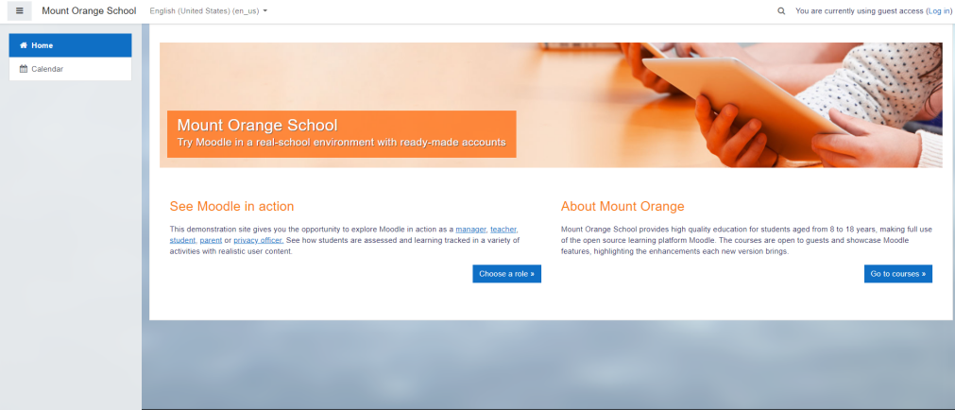

Picture 2.2 Moodle Interface

[Source: school.moodledemo]

## **Database**

Database can be defined or interpreted as a collection of data stored systematically on a computer that can be processed or manipulated using software programs or applications to produce information. The database is a very important aspect in information systems because it functions as a data storage warehouse for further processing. Databases are important because they can organize data, avoid duplication of data, avoid unclear relationships between data and also complex updates. The process of entering and retrieving data to and from data storage media requires software called a database management system. Database Management System or commonly abbreviated as DBMS is a software system that allows database users to maintain, control and also access data practically and efficiently (Termasmedia, 2020).

There are 12 types of databases, including Analytical Database, Operational Database, Distributed Database, Data Warehouse, End-User Database, Real Time Database, Document Oriented Database, In Memory Database, Navigational Database, Hypermedia Database on The Web, External Database, Relational Database (seputarpengetahuan, 2015). The explanation of the 12 types of databases is as follows:

1. Analytical Database

Analytical database is a database for storing information and data taken from operational and external databases. This database consists of data and information summarized and most needed by a management organization and other end-users (seputarpengetahuan, 2015).

1. Operational Database

Operational Database is a database that stores detailed data needed to support the operations of the entire organization. Also known as SADB (subject-area databases). Examples such as: inventory databases, personal databases, customer databases, accounting databases (seputarpengetahuan, 2015).

1. Distributed Database

Distributed database is a local database working group and departments in offices and other work locations. In this database, there are two segments, namely database users and operations, whose data is used and generated only on the site users themselves (seputarpengetahuan, 2015).

1. Data Warehouse

Data warehouse is a database warehouse that stores data from previous years to the present. The data warehouse is the main source of integrated data so that it can be used and utilized by professional users throughout the organization (seputarpengetahuan, 2015).

1. End-User Database

End-user database is a database consisting of data files developed from end-users in each user's workstation. For example, various collections of documents in word processing, spreadsheets and file downloads (seputarpengetahuan, 2015).

1. Real Time Database

Real time database is a database processing system designed to handle the workload of a country which can change, contains continuous data and partially has no effect on time. This database is useful for legal, accounting, banking, multi media and scientific data analysis people (seputarpengetahuan, 2015).

1. Document Oriented Database

Document oriented database is one of the databases that are assembled for a document-oriented application. This system can be applied as a layer on top of a relational database or an object database (seputarpengetahuan, 2015).

1. In Memory Database

In memory database is a database that relies on memory for data storage in a computer (seputarpengetahuan, 2015).

1. Navigational Database

Navigational Database is a database that functions to get or find a database with a combination of object references (seputarpengetahuan, 2015).

1. Hypermedia Database on The Web

Hypermedia database on the web is a collection of multimedia pages that are interrelated on a website. Hypermedia database on the web itself consists of a home page and hyperlinks from multimedia such as images, text, audio graphics (seputarpengetahuan, 2015).

1. External Database

External Database is a database that provides access to external parts. Here the data is stored and used for commercial purposes. Access is also quite easy because it is used for the public and is more efficient ( bootup.ai, 2019).

1. Relational Database

Relational Database is a type of database that is very popular in use. Relational Database is a database that organizes data into a table or several tables from columns and rows with a key that is useful for identifying data on each row (Dictio, 2017).

## **Database Clustering**

According to Hodges (in Billirianto, Rovandi, 2014) Database clustering is a collection of several independent servers which then work together as a single system. The advantages of database clustering are data redundancy, Load balancing, and High Availability:

1. Data Redudancy

Data redundancy in Database Clustering provides advantages in data replication between nodes. Database replication serves to avoid the possibility that not all data will be copied because during the manual data copying process, user data changes may occur. If the master database is damaged, it can be redirected to the slave database immediately. The master-slave replication takes place in realtime where any changes to the master database will automatically change the data in the slave database (Kristian, Rochim, & Widianto, 2015).

1. Load Balancing

In general, load balancing is a balanced distribution of workloads, whereas in internet working, load balancing is a method of distributing loads to several hosts so that the workload is lighter. It aims to shorten the average time doing tasks and can increase processor utility (Muliyantoro, 2013).

1. High Availibility

High Availability is a concept of minimizing down time damage or data loss that occurs on a server or infrastructure. HA aims to provide high-level server services in a timely manner so that when a problem occurs HA can reduce the bad effects that occur due to downtime (dewaweb,2020).

According to Muliyantoro (2013) there are three types of cluster computing architectures. The three types of computer architectures in question are High Availability Clusters / Cluster Failover, Load Balancing Clusters, Compute Clusters. The explanation regarding cluster computing architecture according to Muliyantoro (2013) is as follows:

1. High Availability Clusters

The purpose of a high-availability cluster is to increase the availability of services provided by the cluster. In general, this type of clustering is often referred to as a Failover Cluster. Generally, this cluster has at least two nodes to perform data redundancy which is useful for eliminating failures at one point.

1. Load Balancing Clusters

Load Balancing Clusters are a type of cluster that works by carrying out the process of delivering or distributing the distribution of the workload of the processed data evenly through the nodes that work behind (back-end nodes) so that all operations can run well.

1. Compute Clusters

Compute Clusters are commonly used for computing purposes as opposed to handling I / O based operations such as web or database services. The main difference for this category from other categories is how tightly the nodes are joined together. For example, a computation task may require frequent communication between nodes, this means that the cluster uses the same dedicated network, which is located in very close proximity, and may also be nodes that are homogeneous.

## **Galera Cluster**

According to Pierre (in Fiandrianto, 2015) galera cluster is a solution first introduced by Codership which functions to make MySQL databases become multimaster synchronus. Piere (in Fiandrianto, 2015) also mentioned some of the advantages of using the Galera Cluster, among others:

1. True multimaster

The galera cluster can be used to run write queries to all database servers, unlike master-slave systems which can only write to one server.

1. Synchronus replication method

Each data uses synchronous mode to replicate between cluster members. This method is used to ensure that no data is lost when the database crashes.

1. Data consistency

All cluster member servers have the same data. There is no lagging when inserting data, so it can ensure that the data is consistent across all cluster member servers.

1. Multithreaded slave

This feature makes the galera ready for high workloads. The upper limit of the galera is in accordance with the database server specifications.

1. Hot Stanby

When one of the servers is down, there is no need for reconfiguration which causes downtime, this feature is because the gallery runs as a multimaster database server.

1. Transparent to application

On the user side, the cluster gallery runs like normal MySQL. No special driver is required to connect to the Galera cluster.

1. WAN

Galera has a feature to increase redundancy by placing the server in another area as a WAN backup.

In addition, Pierre (in Fiandrianto, 2015) also explains the limitations that exist in the guidance of the Galera Cluster. The limits mentioned by Pierre (in Fiandrianto, 2015) are as follows :

1) The Galera cluster only supports databases that use the InnoDB engine.

2) All tables in the database in the Galera cluster must have Primary keys to avoid differences in the query execution queue between all Galera cluster members.

3) Does not have a Query cache like the one in the MySQL system.

4) Query logs should be saved as a file.

## **Virtualitation Technology**

Virtualization technology is a technology for making things using software to represent things, such as applications, servers, storage, and virtual networks. Virtualization is a fairly effective way to reduce IT costs while increasing efficiency and agility for all sizes of businesses (Mitra Integrasi Informatika, 2019.

Some of the benefits of virtualization techniques include increasing agility, flexibility, and scalability as well as significantly reducing costs (Mitra Integrasi Informatika, 2019.

There are 3 types of virtualization, namely, server virtualization, network virtualization, and desktop virtualization, the explanation for server, network and desktop virtualization is as follows :

* **Server Virtualitation**

Server virtualization allows multiple operating systems to run on a single physical server. The benefits of server virtualization include IT efficiency, reduced operational costs, increased workload sharing, increased application performance, increased server availability, and eliminated server complexity. Examples of server virtualization are Virtual Machine and Docker (Mitra Integrasi Informatika, 2019).

* **Network Virtualitation**

Network virtualization reproduces the physical network and allows applications to run on virtual networks just as they would on a physical network. Network virtualization represents network services and devices such as logical ports, switches, routers, firewalls, load balancers, VPNs, and so on in a connected workload (Mitra Integrasi Informatika, 2019).

* **Desktop Virtualitation**

Desktop virtualization enables desktop management as a service which enables organizations to respond more quickly to changing work environments and emergency needs. Desktop virtualization can be done quickly at branches, outsourced & offshore employees, and employees using iPads and Android tablets.

## **Virtual Machine**

Virtual machine is software engineering that has the same function as a physical computer with complete building components. Engineering performed by virtual machines is able to perform activities like a computer in general, such as installing applications, creating files, running programs, installing operating systems, updating systems and configurations. (virtualiable, 2020).

Virtual machines have several advantages. The main advantage of a virtual machine is the ease of doing backups and cloning. Other advantages of virtual machines are as follows:

* + - 1. Familiar Interface

The virtual environment is built to resemble the physical hardware environment or host machine, so that users are more familiar with the interface provided by the virtual machine (virtualiable, 2020).

* + - 1. High Availability

Easy application availability and recovery (virtualiable, 2020).

* + - 1. Scalability

Virtual machines allow scalability as needed without adding physical resources (virtualiable, 2020).

* + - 1. Reduction of Cost

Save money by running multiple operating systems on one machine (virtualiable, 2020).

Virtual machines also have some disadvantages when it comes to virtualization. Some of the shortcomings of a virtual machine are as follows :

1. High RAM consumption because each virtual machine will occupy the same space (Virtualiable, 2020).
2. High disk space usage, because it takes all files for each operating system installed on each virtual machine (Virtualiable, 2020).
3. When several virtual machines are running simultaneously on one host computer, the performance becomes unstable (Virtualiable, 2020).

## **Docker**

Docker is an open source application for bringing together the files needed by a software so that it becomes a complete and functional unit. Setting data and supporting files are referred to as images. Furthermore, the image collection is combined in one container called Container.

Docker has been a concern of developers since 2013, introduced by Solomon Hykes at the PyCon US event. Some time after that, Docker was first released in June 2014. Docker was developed by Solomon with colleagues Andrea Luzzardi and Francois-Xavier Bourlet. At that time Docker was an internal dotCloud project. As a result, currently Docker has become a popular platform among developers in various parts of the world, although it is not yet very popular in Indonesia (niagahoster, 2018).

Docker itself is a company that provides container platform services. Docker's capabilities are being able to run various applications with different system configurations, even though they are still on one computer or server device (niagahoster, 2018).

Docker has a lot of components. There are a few components that should know before getting to know docker (niagahoster, 2018), components of the components, among others :

* Docker image: this is a file containing information and instructions for building a container. Image also functions to use and transmit information (Niagahoster, 2018).
* Container: is an environment for packaging and running applications. This includes code, runtime, system tools, and settings. Containers can only access resources that have been specified in the docker image (niagahoster, 2018).
* Docker client: that is, a place where users can send commands such as docker build, docker pull, and docker run to Docker daeomon (niagahoster, 2018).
* Docker Engine Rest API: used to interact with the Docker daemon. This can be accessed by clients via HTTP (niagahoster, 2018).
* Docker host: provides a complete environment for running applications. He is responsible for receiving orders given by the Docker client (Niagahoster, 2018).
* The Docker daemon: it manages Docker images, containers, networks, and storage volumes. The Docker daemon receives a request from the Docker API and will process it (niagahoster, 2018).
* Docker registry: a container for storing Docker images. The Docker image will react according to the command given. For example, when given the docker push command, the docker image will be pushed or shared to the Docker Hub registry (niagahoster, 2018).
* Docker Hub: is a service provided to find and share container images with the team (niagahoster, 2018).

There are many advantages to Docker. One of them is the presence of the container feature. In general, a container is a tool to make it easier to package and distribute something from one place to another. In Linux a container is defined as a system that can be used to provide an isolated system at the operating system level that is run on a single linux kernel (Niagahoster, 2018). Another advantage that Docker has is :

1. Simple configuration

The first advantage of Docker is that its configuration is quite simple and can be adapted to the needs of the application being developed. With just a few lines of code, Docker can create its own environment that is different from the main server environment. This will separate the infrastructure needs from the application environment (Niagahoster, 2018).

2. Multi-Cloud Platform

Not only running on one cloud platform, Docker can run on various cloud platforms, making Docker quite flexible. These are the strengths and benefits of Docker which can be the main reason developers use Docker. Several major cloud service providers in the world have started to provide Docker support for their services (Niagahoster, 2018).

3. Environmental Standardization & Version Control

When upgrading a component the whole environment will usually be broken down. If there is a problem with the process, Docker has a feature that allows immediately roll back to the previous version via the Docker image. This example of using Docker works faster than a Virtual Machine, this is because Docker standardizes the environment by ensuring consistency across several development processes and version updates (Niagahoster, 2018).

4. Isolation

The resources in each application are ensured to be isolated separately by Docker. So the user can adjust the needs of each application without having to affect the configuration of other applications. For example two applications A and B require the first version of the webserver. After the update process, it turns out that application A can only run using the second webserver version so changes must be made to the webserver. Even though application B requires the first version of the webserver on Docker, everything can be resolved because the two applications are indeed connected but are mutually isolated in their configuration (Niagahoster, 2018).

5. Security

Docker ensures running applications cannot affect the container or even provide complete control over traffic flow and management. Another safeguard that Docker does is to set the host OS mount point read-only so user can't change any configuration there unless the user have full access (Niagahoster, 2018).

* 1. **Linux**

Linux is software or operating system software that is open source and is free to obtain or distribute under the GNU license. Linux OS is a derivative of Unix and can be used on a variety of computers. With Linux, users can get complete software with source code. Even users can change or modify the source code, and all that is legal of course under the GNU license (pengertianku, 2017).

Linux distribution or abbreviated as "Linux distro" is a term for the Linux operating system which is packaged with certain software in such a way that it has the interface and features according to the wishes of the maker, of course, in making it use the Linux kernel. There are countless Linux distributions, and more and more are growing over time. Some examples of Linux distributions that are known today, such as SuSE, Red Hat, Debian, Fedora, Ubuntu and many more (pengertianku, 2017).

As an operating system, of course, Linux has advantages and disadvantages. Linux has many advantages including :

* + - 1. Linux is Open Source

The Linux operating system is Open Source and free so it doesn't require a special license when using it (pengertianku, 2017).

* + - 1. Linux supports many languages ​​for programming

Many free tools that can be used. The following is a list of programming languages ​​that are supported on Linux, including C, C ++, C #, namely using Mono Develop, Pascal using FPC and Lazarus, and Javascript Basic / VB (bootup.ai, 2019).

* + - 1. Has an attractive GUI display

Linux has an attractive and user friendly Graphical User Interface (GUI), Linux also has many variations on its GUI (pengertianku, 2017)

* + - 1. Linux has a strong security system

The security system on Linux is superior because it has limited access rights, which means that the gap to enter a Linux system is very minimal. For example, when user want to install an application, user need an online repository. Even though it can be offline, it's very rare for nosy people to create viruses in Linux application extensions (liputan6, 2019).

Linux also has some disadvantages compared to other OS such as Windows. The disadvantages of the Linux operating system include :

1. When using Linux, it can be a little tricky to install Microsoft applications. This is a drawback to Linux for people who are used to Microsoft. Even though Linux already provides a replacement office application, namely Libre Office, Microsoft Office, as the majority of the applications that are often used, is always nice to use (Liputan6, 2019).

2. Quite Difficult for Beginners

For beginners or newbies, using Linux is something that is quite complicated. Even though Linux already provides a GUI (Graphical User Interface) version, there are still several commands that are required to use the Command Line Interface (CLI). For first time amateurs, using Linux will confuse users with Basic Linux Commands (Liputan6, 2019).

* 1. **Ubuntu**

First released in 2004, Ubuntu is a free, open-source Debian-based Linux operating system and distribution. This operating system is built using the Debian infrastructure and consists of servers, desktops, and Linux operating systems (dewaweb, 2020).

Since its release, this operating system has become a favorite of many people because it is easy to install and use. The default desktop environment for Ubuntu is known as Unity, a desktop environment that has a powerful search tool to search all applications and documents on the system. This desktop environment also integrates with other applications such as audio players, video players, and social media. Apart from Unity, there are other environments or environments such as GNOME, XFCE, MATE, KDE, and LXDE (dewaweb, 2020).

Apart from being open source and free, ubuntu is also safe to use.With a built-in firewall and strong virus protection, ubuntu is even safe to use without an antivirus installed (dewaweb, 2020).

* 1. **Ubuntu 16.04.6 Xenial Xerxus**

Ubuntu 16.04.6 Xenial Xerxus is a version of Ubuntu that was released with long-term support. This means that this version of Ubuntu is fully supported in terms of critical security, bugs, and application updates by the company that made Ubuntu, namely Canonical.

Full support from Canoncial will end in 2021, but Canoncial will continue to provide some critical updates as ESM (Enterprise Service Management). These critical updates only apply to Ubuntu customers who use the enterprise version and server version (omgbuntu, 2020).

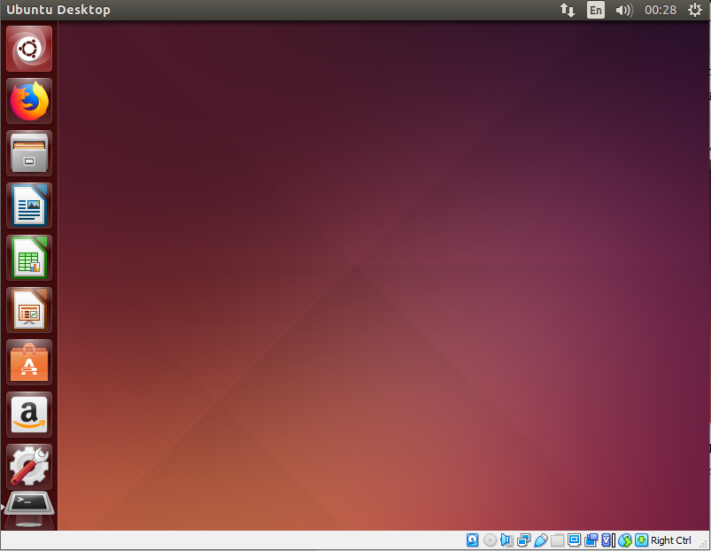

Picture 2.3 Ubuntu 16.04.6 Xenial Xerxus Interface

[Source: omgbuntu, 2020]

* 1. **Httperf**

According to Adnan (2016) Httperf is a tool for measuring web server performance. It provides flexible facilities for generating various HTTP workloads and for measuring server performance. HTTF's focus is not on implementing one specific benchmark, but on providing powerful, high performance tools that facilitate building both micro and macro level benchmarks.

In Httperf there are several important points that are measured for benchmarking purposes. The points seen during measurement by the HTTperf utility are reply rate, reply time, cpu time, and client timeout (Github, 2020).

In the test results with the HTTperf utility there will be a reply rate point which will indicate the minimum, average and maximum replies per second with a standard deviation of 0. The latest version of HTTperf collects one sample rate every 5 seconds which will also be displayed in the reply rate section of the results. httperf testing (github, 2020).

The reply time is also one of the results displayed when testing with the HTPperf utility. The reply time indicates how long it takes for the server to respond and how long it takes for the server to receive a reply from a given request (github, 2020).

CPU time is the amount of time in which the central processing unit (CPU) is used to process instructions from a computer program or operating system (Techopedia, 2014). CPU time on the results displayed when testing with the HTPperf utility displays how long the CPU executes in user mode, and also in system mode in seconds, and also displays the suitability of command execution in user and system mode in percent (github, 2020).

Client timeouts on tests with the HTperf utility are included in the error section of the httpperf itself. The error section of httpperf displays statistics on errors that occurred during testing. Client timeout means that when every request is sent to the server, the watchdog timer will start. The watchdog timer itself is a facility whose function is to restart itself when it reaches a certain time. If no response is received by the server until the watchdog timer expires then it is counted as a client timeout (github, 2020).

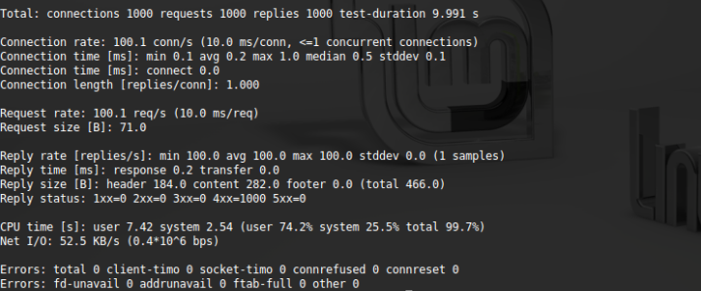

Picture 2.4 Httperf Result

[Source : old.baskoroadi, 2012]

# **CHAPTER III**

# **RESEARCH METHOD**

This chapter discusses the analysis and design of the Docker implementation on moodle with the MariaDB database clustered by galera clusters. The implementation process of docker on moodle with MariaDB database which is clustered with galera clusters starting from the installation of Ubuntu Desktop 16.04.6 Xenial Xerxus, installing Moodle to testing the connection between database nodes, while for the testing phase of implementing docker on moodle with clustered MariaDB database with the galera cluster will be discussed in the next chapter.

* 1. **Analysis of the Current System**

Virtualization technology plays a very important role in saving costs and also increasing performance on the server. Virtualization technology is technology that allows a virtual form of something that is physical, for example, an operating system. Virtualization technology that is familiar and also often used is virtual machines.

A virtual machine is computer software that has properties like a physical computer, has grouped resource allocations, can run operating systems and applications separately from the physical. Virtual machines run on a physical computer where each task and resource allocation is divided and separated from one virtual machine to another (medium, 2020). Some of the advantages that can be found in virtual machines are High Availability, which means that the virtual machine has easy application availability and recovery. The advantage of a virtual machine is the ease of cloning a virtual machine.

Although virtual machines provide high availability (high availability) on servers, virtual machines have some fatal drawbacks where virtual machines consume high RAM because each virtual machine will occupy the same space as the physical device. Virtual machines that can virtualize complex systems take up the allocation of hardware on the main computer, such as large virtual data storage. This can trigger the server to be slow in returning requests, disconnect from services that are currently running, even on some types of servers it can cause a critical message in the form of a warning on the server which informs that a problem occurred on the server when receiving requests if the server receives many requests. Therefore the use of virtual machines is recommended for devices that have high enough specs to get the function that is truly desired (Virtualiable, 2020). The architecture of the virtual machine can be seen in picture 3.1

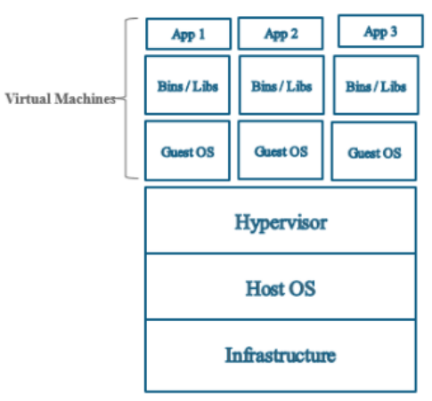

Picture 3.1 Virtual Machine Architecture

[Source : geekflare, 2019]

* 1. **System Proposal**

Seeing the high RAM usage in the use of Virtual Machines, this study proposes a system with another virtualization technology, namely Docker. Docker virtualizes on top of the kernel that runs on the operating system below it (Rizqiwati, Suryanto, & Syaifuddin, 2018). When the operating system used in the host machine is Linux, the docker virtualization runs on that operating system and does not require another operating system as in a virtual machine, so that Docker only uses very small memory resources and can run quickly. Docker settings data and supporting files are referred to as images. Furthermore, the image collection is combined in one, called container. Docker architecture can be seen in the picture 3.2.

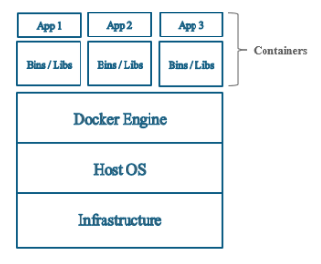

Picture 3.2 Docker Architecture

[Source : geekflare, 2019]

In this paper, a docker implementation will be carried out on moodle with a MariaDB database clustered with a galera cluster which will be able to help ease server performance in serving many requests on the server. The docker implementation uses one network that will connect three containers. The three containers are one container that uses the Moodle image, and two database containers that act as node1 and node2 using images from bitnami / galeracluster. In the use of database clusters that exist in the image from bitnami / galeracluster using Load Balancing Clusters because the database cluster on the bitnami / galeracluster image is a cluster that functions to distribute the load between two different database nodes, while the database method used is a multi-master database, because The master database used in the Moodle application is stored on two separate nodes. The database architecture on the system can be seen in the picture 3.3.

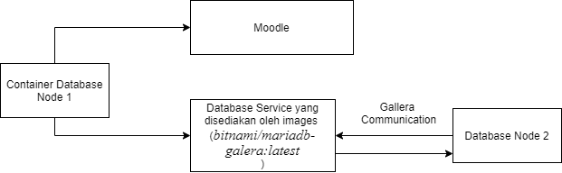

Picture 3.3MariaDB database clustered by galera cluster

The implementation results will be tested for performance (benchmarking) using the HTPperf utility on linux.

* 1. **System Analysis**

The system analysis stage is carried out by analyzing what is needed to help the system development process. System analysis consists of analysis of hardware (hardware) and analysis of software (software). The hardware used is 1 PC which acts as a server. Hardware specifications of the PC that are used as servers can be seen in the table 3.1**.**

Table 3.1 Hardware Specification

| **Hardware** | **Spec** |
| --- | --- |
| Processesor | AMD Ryzen 5 3400G |
| RAM | 8GB |
| GPU | AMD Radeon(TM) RX Vega 11 Graphics |

Table 3.2 displays the software specifications used in the implementation stage.

Table 3.2 Software Specification

| **Software** | **Specification** |
| --- | --- |
| Operating System | Ubuntu Desktop 16.04.6 Xenial Xerxus |
| Docker Engine | 18.09.7 |
| Docker Image Database Cluster | bitnami/mariadb-galera:latest |
| Docker Image Moodle | prasta/moodle:latest |

* 1. **Research Method**

The initial stage of the research was to install ubuntu desktop 16.04.6 Xenial Xerxus. The next step was to install the docker engine on Ubuntu Desktop 16.04.6 Xenial Xerxus. After that, pull the docker image for moodle (prasta / moodle) and the docker image for the MariaDB database which is clustered with the galera cluster (bitnami / mariadb-galera) on dockerhub. Then create a network which will be used to unite the containers that will be made into one network (network). After creating the network, the Moodle Container, and the database (node1 and node2) can be created by including the network name to become one network, then install moodle by selecting the database in the container database (node1), after success, test the data integration on two database nodes (node1 and node2). After the two database nodes can be confirmed to be integrated, the next step is to measure the performance (benchmarking) on ​​the server with the HTPperf utility on Linux. After doing the test (benchmarking), the server performance test is also carried out from using the CPU. The chart of the stages of the docker implementation research can be seen in Picture 3.4.

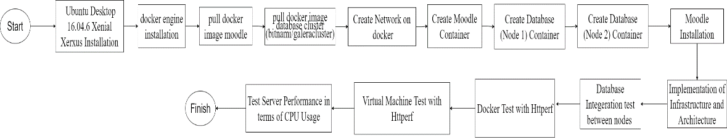

Picture 3.4 System Development Chart of docker implementation on moodle with MariaDB database clustered by galera cluster

* + 1. **Installing Ubuntu Desktop 16.04.6 Xenial Xerxus**

At this stage, the Linux operating system will be installed with the Ubuntu Desktop 16.04.6 Xenial Xerxus variant of the ubuntu distro. The installation steps can be described as follows :

1. **Download ISO Ubuntu Desktop 16.04.6 Xenial Xerxus**

ISO Ubuntu Desktop 16.04.6 Xenial Xerxus can be downloaded on the official ubuntu web, namely: https://releases.ubuntu.com/16.04/, as shown in picture 3.5.

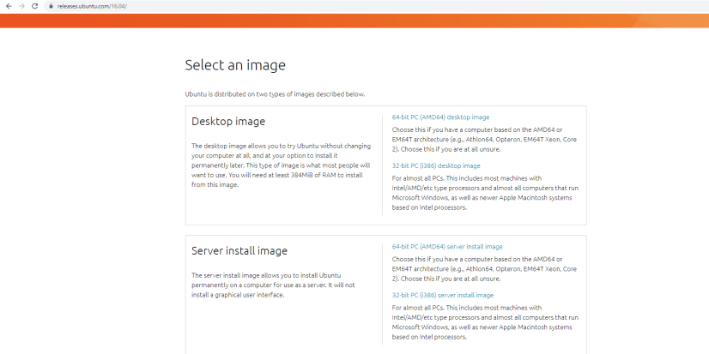

Picture 3.5 Ubuntu Web Interface

[Source : <https://releases.ubuntu.com/16.04/> ]

1. **Check Hard Disk Type**

On hard drives, there are two types of hard drives, namely the Guid Partition Table (GPT) and the Master Boot Record (MBR). Checking the hard disk type on a Windows operating system can be done by opening a command prompt with the administrator role and then typing the diskpart command followed by the list disk command. The command prompt display can be seen in picture 3.6.

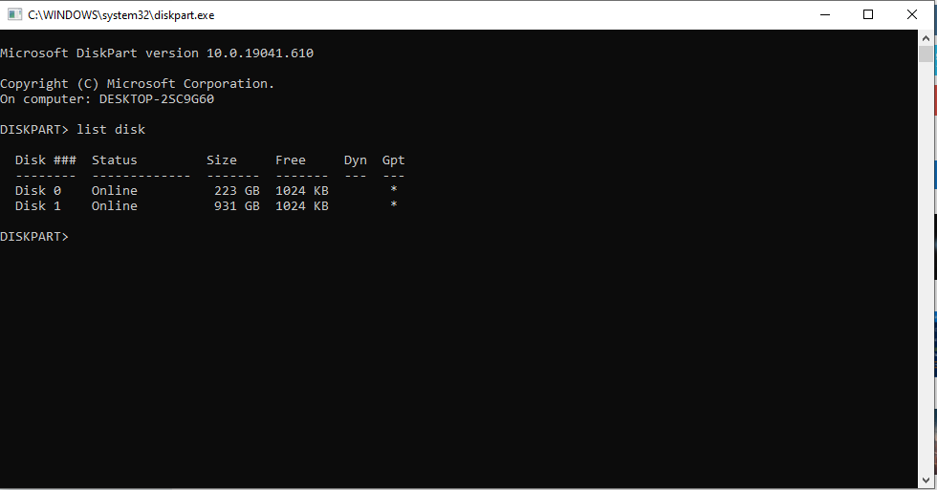

Picture 3.6 Command Pompt

The information displayed by the list disk command can be seen in the GPT column. If there is a star in the Gpt column, the hard drive type is GPT. If the Gpt column does not have a star, then the hard drive type is MBR.

1. **Make a Bootable Device**

A bootable device is a storage medium in which there is an operating system. To make a USB drive a bootable device, user can use the help of the Rufus software. The appearance of the Rufus application can be seen in picture 3.7.

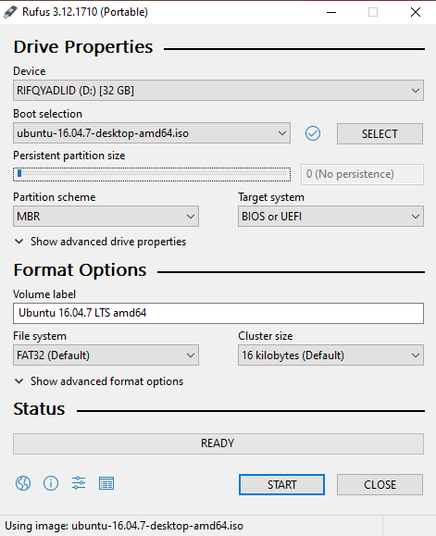

Picture 3.7 Rufus

An important component that needs to be considered in making a bootable device with Rufus is the Device section which is the name of the storage media. Boot Selection is an ISO file from the operating system and partition scheme is a type of hard drive for a device. It should also be noted that in making a bootable device, the storage media that is used as a bootable device must be empty, if the storage media still has contents in it, the storage media must be formatted first.

1. **BIOS Configuration (Change Boot Priority)**

Changing the Boot Priority requires configuration settings in the BIOS. Boot Priority is changed so that the CPU does Boot by reading the Bootable Device that has been created, not on the CPU's internal hard drive. This process is important so that the system can install an operating system that is in the boot device. To enter the BIOS configuration, press the del key on the keyboard (can be different for each brand of device).

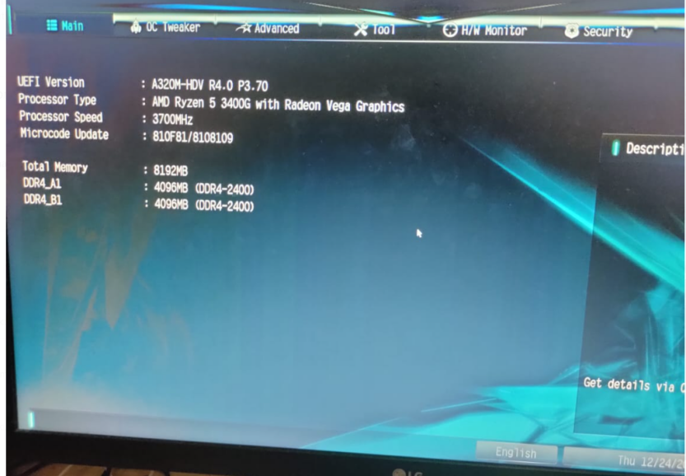

Picture 3.8 BIOS Settings

After entering BIOS Settings in picture 3.8 select the Boot menu to change the boot priority. The boot menu can be seen in picture 3.9.

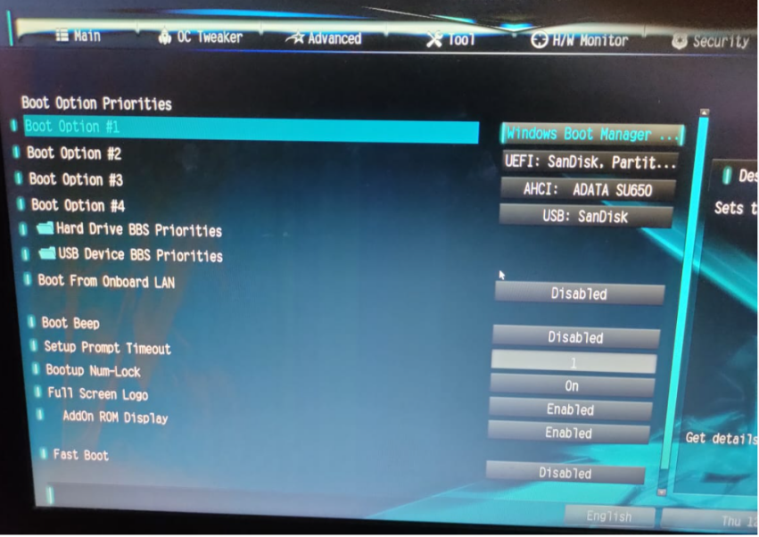

Picture 3.9 Menu Boot

Change Boot Option 1 to usb drive name. The name of the usb drive is often the brand name of the usb, in this case the name of the usb drive is SanDisk which is already connected to the server. Do Save and Exit, then when booting the CPU will read the Bootable Device that was created earlier. After configuring the BIOS, the display for the ubuntu installation will appear as shown in picture 3.10.

1. **Ubuntu Instalation Page**

On the ubuntu installation page shown in picture 3.10, there is a language selection and two installation options. The first option is to try ubuntu which will only display the ubuntu demo, without installing the operating system, and to install ubuntu select the second option, namely Install Ubuntu.

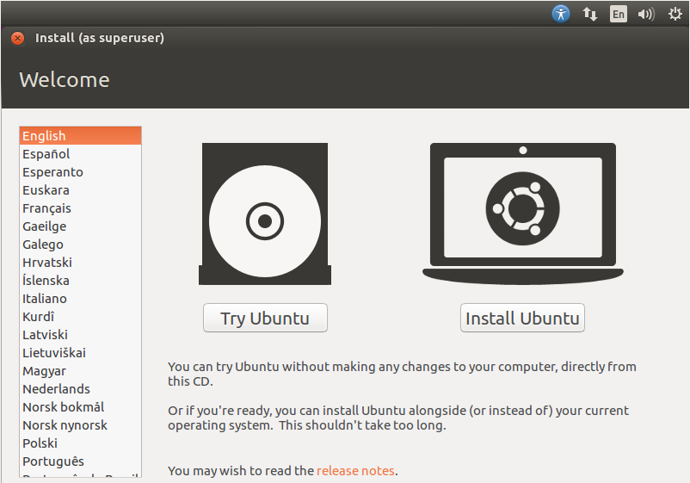

Picture 3.10 Ubuntu Installation

1. **Preparing to Install Ubuntu**

After selecting install ubuntu, the installation process will continue at the Preparing to Install Ubuntu stage as shown in picture 3.11. At this stage there are two options. The first option will allow the system to download the latest application packages during the installation process. This process requires an internet connection, and makes the installation process relatively longer depending on the speed of the internet connection. The second option will allow the system to download several third-party applications related to graphics and audio and other media. This option is recommended to be checked so that later when Ubuntu is installed, it can immediately use third-party applications such as browsers and mp3 music players.

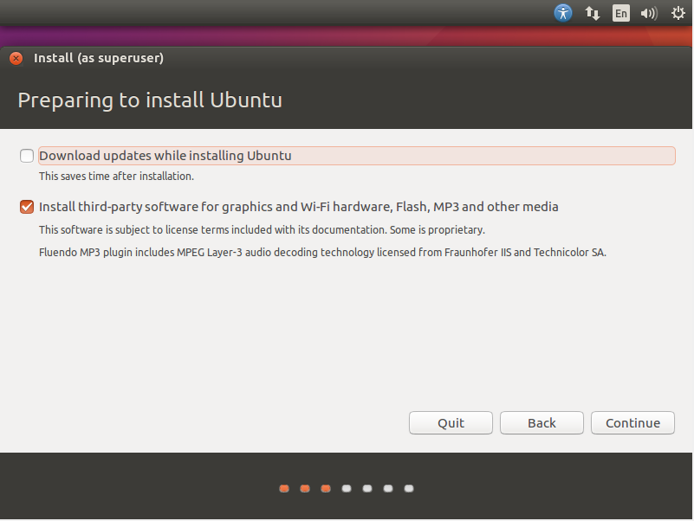

Picture 3.11 Preparing to install Ubuntu

1. **Installation type**

On an empty installation type server and don't have any files in it, user can immediately select Erase disk and install Ubuntu, because there is no partition table in it. The installation type stage can be seen in picture 3.12.

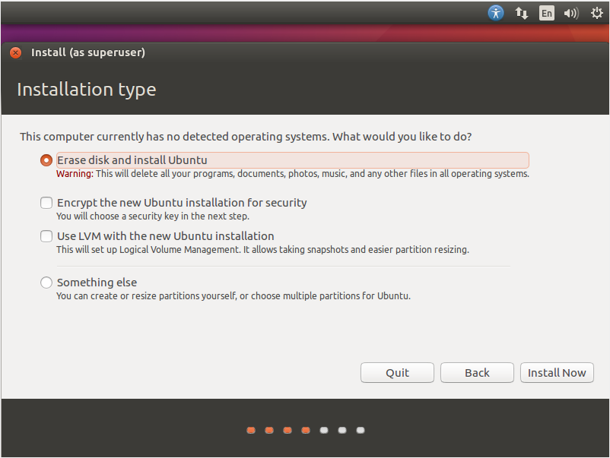

Picture 3.12 Installation Type

1. **Time Zone and Location**

Determination of the location on the ubuntu installation also determines the time zone that will be used on the server when Ubuntu is installed later. The stage of determining the time zone and location can be seen in the picture 3.13.

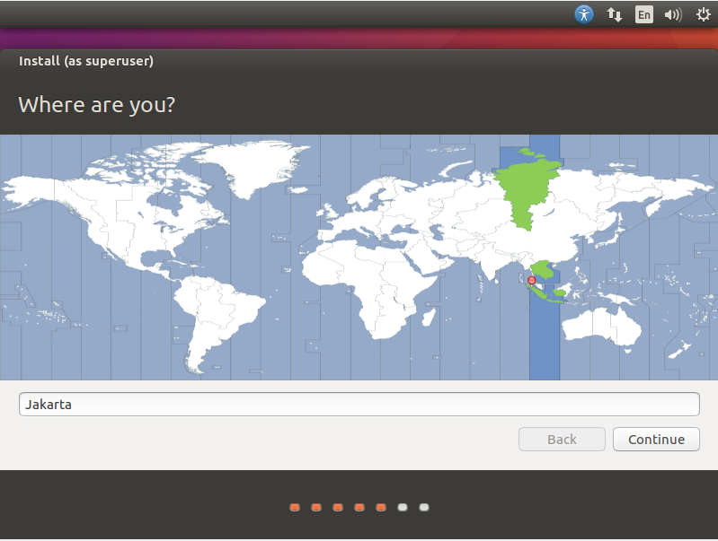

Picture 3.13 Choosing Time Zone and Location

1. **Keyboard Layout**

Selection of Keyboard Structure, useful for equating the standard letters that exist in a country. The country of Indonesia has the same keyboard structure as the default on the Ubuntu installation, namely English (US). The Keyboard Layout selection can be seen in picture 3.14.

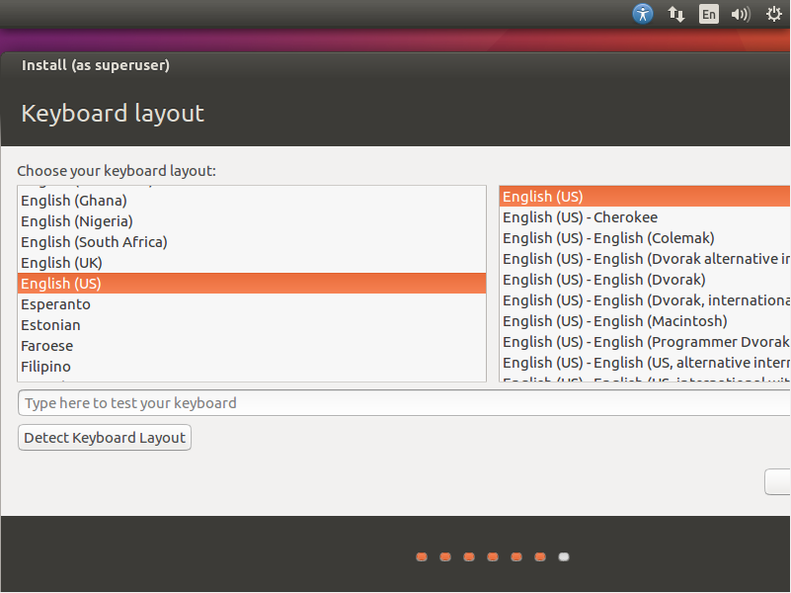

Picture 3.14 Keyboard layout

1. **Data User**

The stage of filling in user data (who are you?) As can be seen in picture 3.15, is the stage for filling in User data which includes data for Computer Name, Computer username, password for user and confirmation for user password that has been filled in. In this study, the username and computer name that are entered are made the same, namely rifqyad.

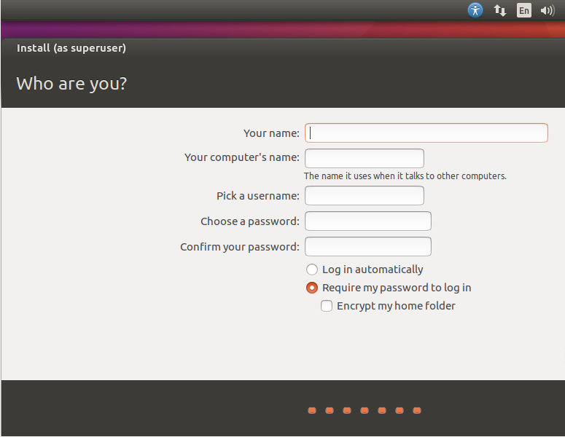

Picture 3.15 Who are you ? Interface

After performing the steps above, the Ubuntu installation process will begin. The speed of the Ubuntu installation process is in accordance with the speed of the hard disk processing data on the server. The ubuntu installation process can be seen in picture 3.16.

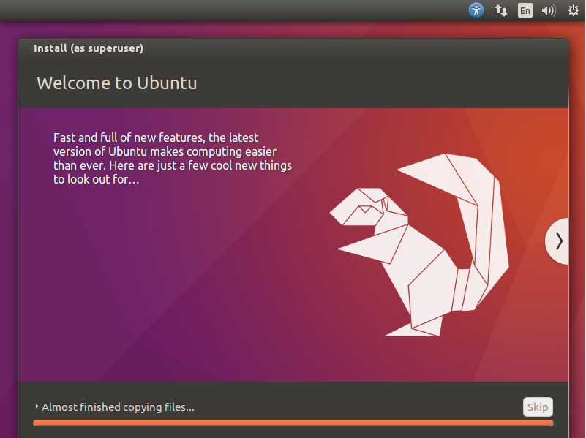

Picture 3.16 Ubuntu Instalation Process

* + 1. **Docker Engine Instalation**

Before installing Docker Engine it is recommended to update Ubuntu. To do an update on Ubuntu user have to use access as root. To perform the update as well as enter access to the root can be done by command :

“sudo apt update”.

The update speed on ubuntu depends on the internet speed. The ubuntu update process can be seen in picture 3.17.

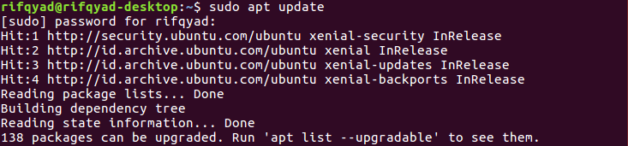

Picture 3.17 Ubuntu Update

After updating ubuntu, docker can be installed using the command:

“apt-get install docker.io”.

The above command must be run using root access. Ubuntu will ask for approval to use space on the hard disk, if agree to install the Docker engine then answer with 'yes'. Docker installation can be seen in picture 3.18.

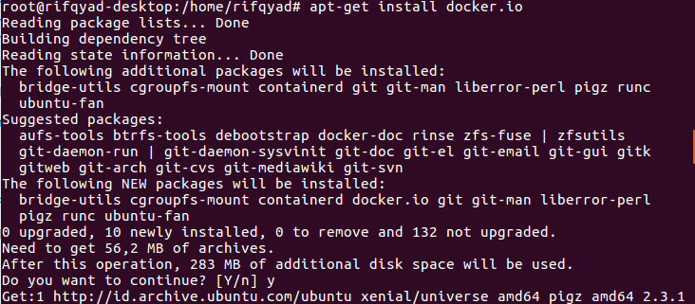

Picture 3.18 Install Docker Engine

To ensure that Docker has been installed correctly as well as knowing which version of docker is installed, use the command :

“docker version”.

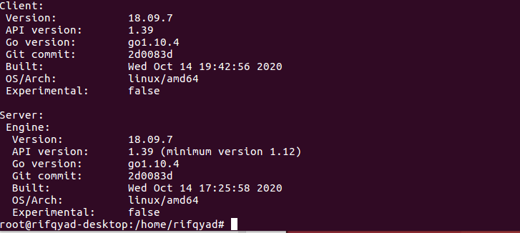

Picture 3.19 Docker Version

It can be seen in picture 3.19 the docker version used is 18.09.7 with API version 1.39.

* + 1. **Pull Docker Image Moodle**

The next step after a successful docker installation is to pull the docker image. The image will be pulled through the registry in dockerhub. Docker image Moodle that will be used in this research is prasta / moodle: latest. Pull the Moodle Image on the docker by command:

“docker pull prasta/moodle:latest”.

The pull image speed depends on the internet connection. The pull image process can be seen in picture 3.20.

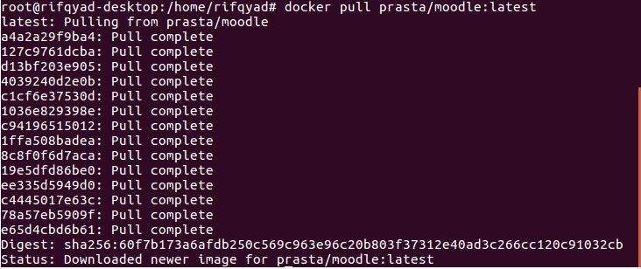

Picture 3.20 Pull Image Moodle Process

* + 1. **Pull Docker Image Database Cluster bitnami/mariadb-galera**

The next step is to pull the image for the MariaDB database which is clustered with the galera cluster as shown in picture 3.21. The Docker image used is the bitnami image, namely bitnami/ mariadb-galera. Pull images can be done with the command 'docker pull bitnami / mariadb-galera'. The pull image speed depends on the internet connection.

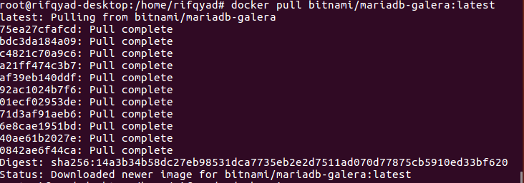

Picture 3.21 Proses Pull Image bitnami/mariadb-galera

To view existing images that have been pulled through the registry on dockerhub, use the command :

“docker images”.

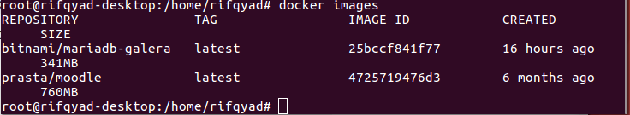

Picture 3.22 List Docker Images

It can be seen in picture 3.22 that the image required is the image bitnami / mariadb-galera and image prasta / moodle: latest.

* + 1. **Creating a Network in Docker**

The isolated docker containers can communicate with each other when they are on the same network. Docker networks can be created with the command:

"Docker network create moodle".

'Moodle' is the name of the network that was created. When creating a network, Docker automatically gives an id to the created network. The id that is formed on the Moodle network is: B1761281165c. Docker creation can be seen in picture 3.23.



Picture 3.23 Making Network

To see the networks that have been created in Docker, use the command :

“docker network ls”.

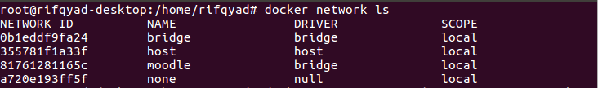

Picture 3.24 List Network

It can be seen in picture 3.24 that the Moodle network has been formed, as a network for the Moodle container and the container database to communicate and be connected so that the Moodle container can access the container database as its database. This means that when selecting the Moodle database, the Moodle container can recognize the name of the created database container and can use it as the Moodle database. Network bridge, host, and none are the default networks provided by docker so that if a container is created without including the network, docker will set the container to enter one of the default networks provided by docker.

* + 1. **Creating a Moodle Container**

Container is an application package in docker which acts as a container to run an application. In making a Moodle Container there are several parameters, namely name, network, detach and port. Moodle containers can be created with commands :

“docker run -d --name moodle_service --network moodle -d -p 80:80 prasta/moodle:latest”.



Picture 3.25 Creating a Moodle Container

In picture 3.25, there are several parameters that are included when creating the container. Paramater name functions to name the container, network parameter functions to register the container on the network that has been created, --port functions to expose the ports in the container to the port of the host machine. The command ends with the name of the images that user want to use.

* + 1. **Creating a Container Database (Node1)**

A Node1 Database Container can be created using an image from bitnami / mariadb-galera. Containers can be created by command :

“docker run -d --name mariadb-galera-0 \

-e MARIADB_GALERA_CLUSTER_NAME=galeracluster \

-e MARIADB_GALERA_MARIABACKUP_USER=galerauserbackup \

-e MARIADB_ROOT_PASSWORD=rifqyadli123 \

-e MARIADB_USER=rifqy \

-e MARIADB_PASSWORD=rifqyadli123 \

-e MARIADB_DATABASE=database_rifqy \

-e MARIADB_REPLICATION_USER=my_replication_user \

-e MARIADB_REPLICATION_PASSWORD=my_replication_password \

bitnami/mariadb-galera:latest”.

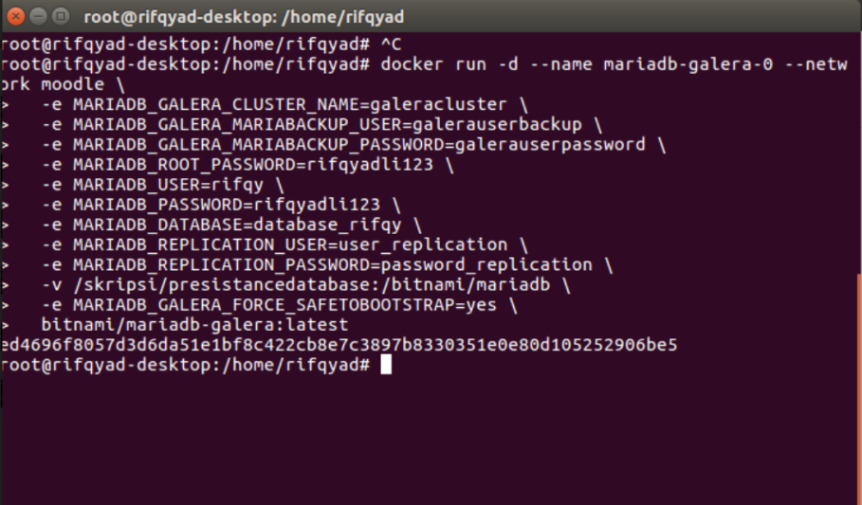

Picture 3.26 Create a Container Database (Node 1)

In picture 3.26, there are several parameters used in creating a database container on Node1, including --name, --network, -v and -e. The --name parameter is a parameter that is filled with the name of the container, --network is a parameter that is filled in by the network name that has been created, -v is the volume on the host machine which is used as a place for data in the database to be stored in the machine (Presisting Database), -e filled with environment variables. There are several environment variables that are filled in the creation of the Container Database on Node1, the environments are :

1. MARIADB_GALERA_CLUSTER_NAME

Environment variable for the name of the cluster that was created when the container was run. In this study, the cluster name used is galeracluster.

1. MARIADB_GALERA_MARIABACKUP_USER

Environment variable for User backup added to the database. In this study, the user backup used is the default user, namely galerauserbackup.

1. MARIADB_GALERA_MARIABACKUP_Password

Environment variable for Password backup added to the database. In this study, the backup password used is the default password, namely galerauserpassword.

1. MARIADB_ROOT_PASSWORD

Environment variable for the password used when logging in with the parent user (Root). In this study, the root password is filled with rifqyadli123.

1. MARIADB_USER

Environment variable for other User databases created at the time the container is run (other than the root user). For database users other than root, it is filled with rifqy.

1. MARIADB_PASSWORD

Environment variable for the password for the user database created. In this study, the password used for users other than root is rifqyadli123.

1. MARIADB_DATABASE

Environment variable for the Database which is automatically created when the container is run. In this research, the database is filled with database_rifqy.

1. MARIADB_REPLICATION_USER

Environment variable for User for database replication. In this study, users for database replication are inputted with the default user, namely user_replication.

1. MARIADB_REPLICATION_PASSWORD

Environment variable for password for database replication user. In this study, the password for database replication is inputted with the default password, namely password_replication.

1. MARIADB_GALERA_FORCE_SAETOBOOTSTRAP

Environment variable to prevent data loss when the database node dies. This environment variable is executed by typing "yes" as its value.

Container creation is accompanied by the image name which is used at the end of the command. The image used is bitnami / mariadb-galera.

* + 1. **Creating a Container Database (Node2)**

Creating a Node2 Database Container is almost the same as creating a Node1 Database Container. Creating Database Node2 containers also uses the same image assistance as Node1, namely images from bitnami / mariadb-galera. The command for creating a container on the node 2 database can be seen in picture 3.27.

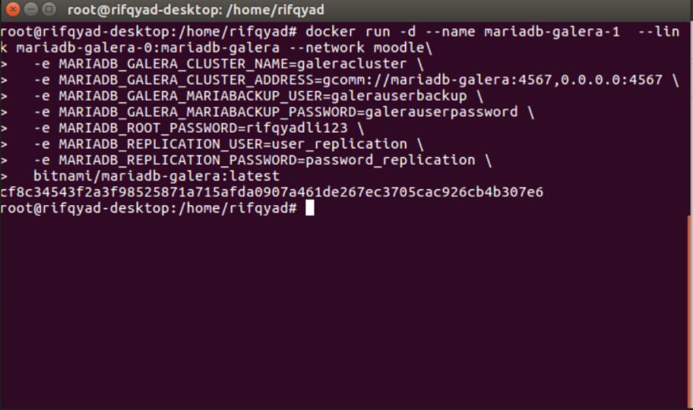

Picture 3.27 Create a Container Database (Node 2)

In making the Container Database Node2, the parameters and Environment variables are almost the same as the parameters and Environment variables in the Container Database Node1, it's just that the Environment key on the container database node2 has an additional environment key, namely MARIADB_GALERA_CLUSTER_ADDRESS which points to the container database address node1 so that it can be connected. Some of the environment variables used in creating the node2 container database are as follows :

1. MARIADB_GALERA_CLUSTER_NAME

Environment variable for the name of the cluster that was created when the container was run. In this study, the cluster name used is galeracluster.

1. MARIADB_GALERA_CLUSTER_ADDRESS

Environment variable that refers to the node1 container database address so that the container database can be connected. In this study, the address gcomm: // mariadb-galera: 4657, 0.0.0.0:4567 is used where 4567 is the port that the firewall must allow to cluster.

1. MARIADB_GALERA_MARIABACKUP_USER

Environment variable for User backup added to the database. In this study, the user backup used is the default user, namely galerauserbackup.

1. MARIADB_GALERA_MARIABACKUP_Password

Environment variable for Password backup added to the database. In this study, the backup password used is the default password, namely galerauserpassword.

1. MARIADB_ROOT_PASSWORD

Environment variable for the password used when logging in with the parent user (Root). In this study, the root password is filled with rifqyadli123.

1. MARIADB_REPLICATION_USER

Environment variable for User for database replication. In this study, users for database replication are inputted with the default user, namely user_replication.

1. MARIADB_REPLICATION_PASSWORD

Environment variable for password for database replication user. In this study, the password for database replication is inputted with the default password, namely password_replication.

To ensure that all containers are on the same network, check with this command :

“docker network inspect moodle”.

where "moodle" is the name of the network that was created. The output of the above command can be seen in picture 3.28.

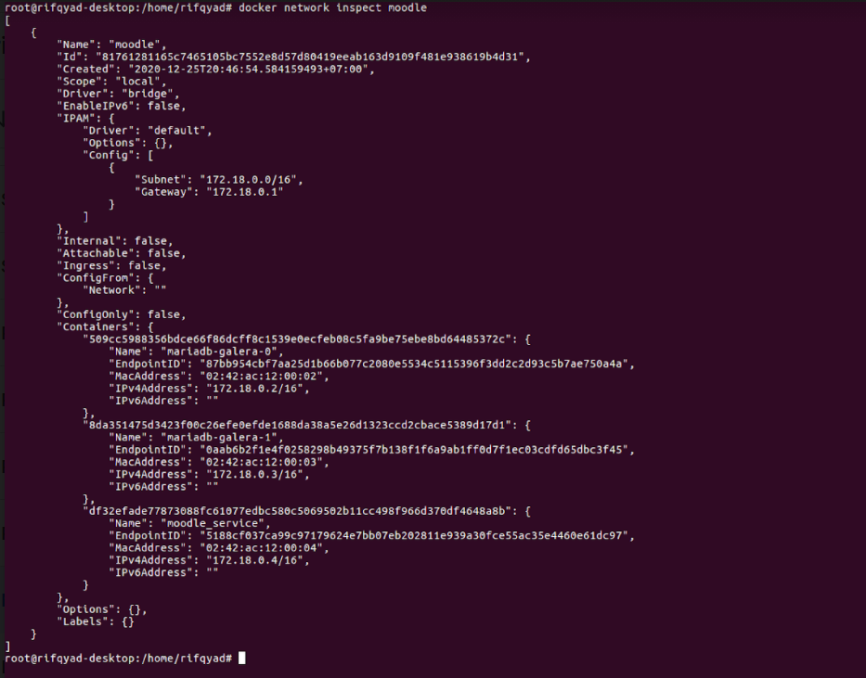

Picture 3.28 Docker Network Inspect

It can be seen in picture 3.28 in the containers section, 3 containers have been registered with the names moodle_service, mariadb-galera-1, mariadb-galera-0. Moodle_service is the container name for moodle, mariadb-galera-0 is the container name for the node1 database, and mariadb-galera-1 is the container name for the node2 database.

* + 1. **Moodle Instalation**

The next step is to install Moodle. Installing Moodle can be done by accessing http: // $ host-ip-address on a browser. The steps for installing Moodle are as follows :

1. Choosing Language

The first step in installing Moodle is to choose the language that will be used in Moodle, in this case the language chosen is English. The language selection installation steps can be seen in picture 3.29.

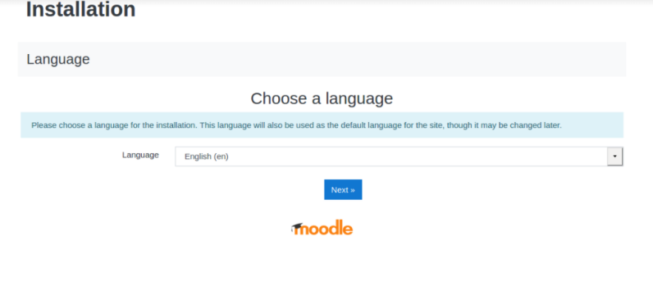

Picture 3.29 Choosing Language

1. Choosing Path

Path selection is done to determine where moodle data will be placed. In this study, the moodle data was placed in the path / var / www / html / moodledata, while the moodle directory was placed in / var / www / html / moodle. The path selection process can be seen in picture 3.30.

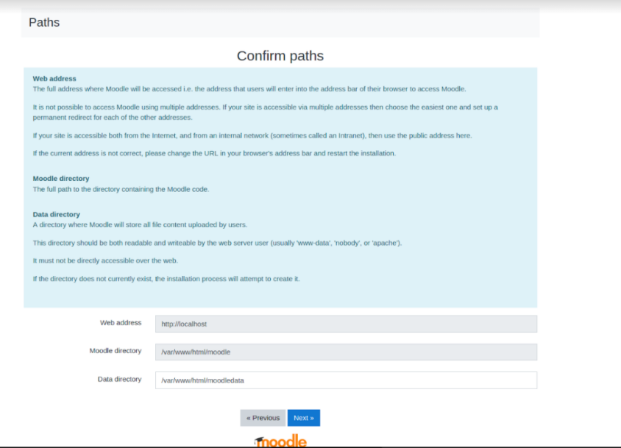

Picture 3.30 Pilih Path

1. Choosing Database

At the database selection stage, the MariaDB database is selected according to the image and container used. The process of selecting the database type can be seen in picture 3.31.

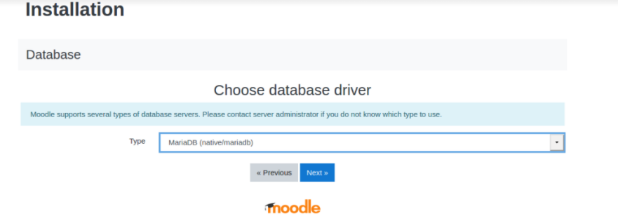

Picture 3.31 Choosing Database Service

1. Database Settings

After selecting the database service used, the next step is to configure the database settings. For database-host is the container name for database node1, namely mariadb-galera-0. The database name used in this database settings is a database called moodle. In this study, the database user used is root, where root has the highest access rights in the container database that has been created. The database settings process can be seen in picture 3.32.

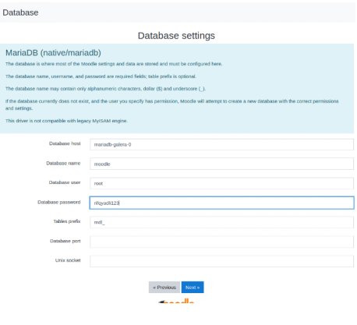

Picture 3.32 Databse Settings

1. Check the Minimum Requiretments

After Moodle ensures that the entire environment meets the minimum requirements as shown in picture 3.33, continue by clicking the continue button.

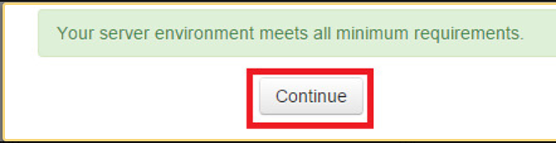

Picture 3.33 Moodle Check the Minimum Requiretments

After the continue button is clicked on the Moodle installation process will begin. If the Moodle installation process is successful, a page will appear indicating successful Moodle installation as shown in picture 3.34.

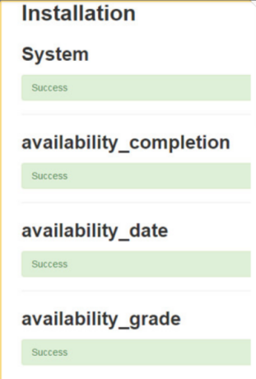

Picture 3.34 Moodle Instalation Success

1. Admin data filling

The next step is filling in the admin (super user) data. Super admin will have access to all operations in Moodle. The process of filling in admin data can be seen in picture 3.35.

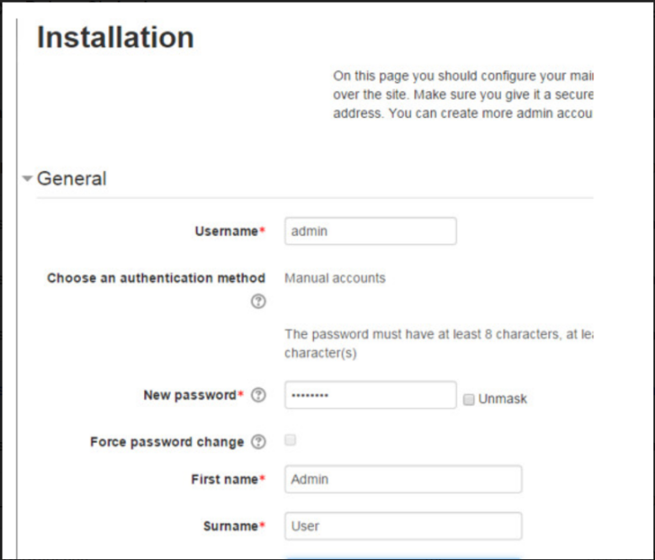

Picture 3.35 Admin Data Filling

In this study, the username used for the super user is admin, for the first name it is also filled with the name Admin and Surname with the name User.

1. Dashboard Moodle

After filling in the admin page, Moodle will direct user to the Moodle Dashboard page where all course creation operations, users and more can be done. The dashboard display on Moodle can be seen in picture 3.36.

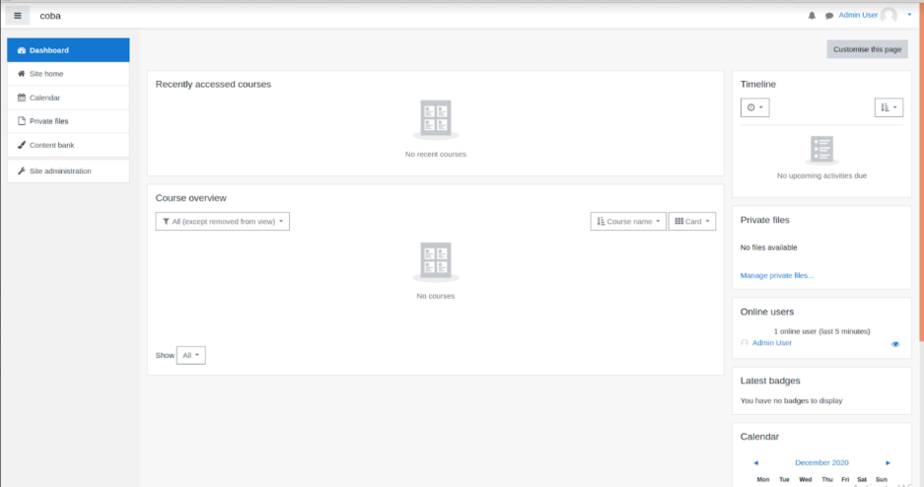

Picture 3.36 Dashboard Moodle

* + 1. **Test for Database Integration between Nodes**

After creating three containers that are interconnected on one network, the three containers are Moodle containers, and two container node databases have been clustered. The node1 database container has a volume on the host machine to maintain its data in case of a container failure. This volume is created when running a container with the -v parameter. The architecture of the system can be seen in picture 3.37.

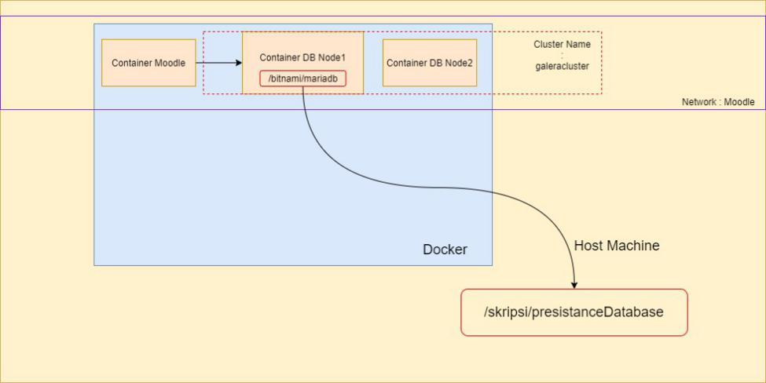

Picture 3.37 Docker Architecture System

As seen in the architecture in picture 3.37, the node1 database container must be integrated with the node2 db container. To check whether the container databases are connected to each other, enter one of the containers and check wsrep_cluster_size. Wsrep_cluster_size will display information in the form of how many nodes to cluster. To enter and access the container, use the command :

“docker exec -it mariadb-galera-0 bash”

Mariadb-galera-0 is the name of the container accesssed. After entering the container, enter the database with the command :

“mysql -u root -p”

Enter the password that was created when running the container, as shown in picture 3.38.



Picture 3.38 command to enter the container and database

After entering the database, check wsrep_cluster_size with the command :

“show status like ‘wsrep_cluster_size”

If the number of wsrep_cluster_size is the same as the number of nodes, then it can be ascertained that the nodes between databases are integrated with each other.

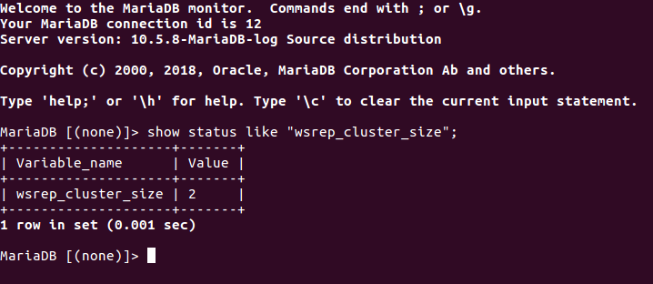

Picture 3.39 Info displayed wsrep_cluster_size

In picture 3.39 it can be seen that the wsrep_cluster_size is 2, according to the number of nodes created. This means that the two container node databases that are created are integrated and connected to each other.

# **Chapter IV**

# **Result and Discussion**

This chapter discusses the results of testing the implementation of Docker on Moodle with the MariaDB database which is clustered with the galera cluster. Testing is done on CPU performance with the HTPperf utility, by measuring the reply rate, reply time, cpu time, and client timeout**.**

* 1. **Implementation of Infrastructure and Architecture**

There are several components that need to be configured when building a ready-made architecture. The infrastructure used is a server that runs as a dedicated server, not as a virtual machine. Researchers do not have to install additional applications to create virtual machines such as VMware and VirtualBox.

* + 1. **Operating System**

The operating system available on Linux Ubuntu 16.04 is divided into two, namely the server and desktop versions. This study uses the Ubuntu Server 16.04.6 LTS desktop version of Xenial Xerus. Picture 4.1 presents a view of the Ubuntu Server 16.04.6 Xenial Xerxus operating system.

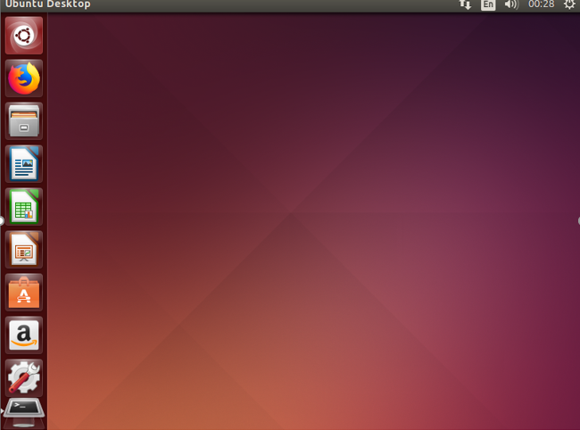

Picture 4.1 Ubuntu 16.04.6 Xenial Xerxus Desktop Interface

[Sumber: omgbuntu, 2020]

* + 1. **Docker**

This research uses docker.io version 18.09.7 with api version 1.39. The docker version can be seen in picture 4.2.



Picture 4.2 Docker Version

* + 1. **Docker Network**

This research uses a docker network named Moodle to connect the containers to be created, so that they can communicate with each other. Networks that have been created can be checked with the command "docker network inspect moodle", the results to be displayed can be seen in picture 4.3.

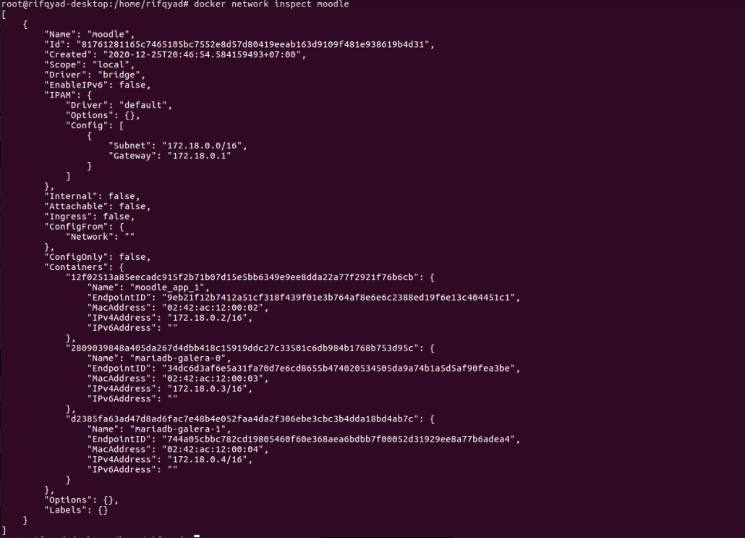

Picture 4.3 Docker Network Inspect

* + 1. **Docker Images**

In this study, 2 docker images were used, namely docker image moodle prasta/moodle: latest and docker image for database clusters, namely bitnami /mariadb-galera: latest.

* + 1. **Docker Container**

In this study, three docker containers were made, namely one docker container for moodle using the docker images prasta / moodle: latest and two container databases that act as node1 and node2, where node1 and node2 are database nodes created using image bitnami / mariadb- galera: latest, where node1 acts as the master node and node 2 as a regular database node.

* + 1. **Httperf**

In this study, benchmarking was carried out with the HTPperf utility on Linux, with trials of 800, 1000, and 1200 requests with 50, 80, 100 requests per second. The following commands are used to perform benchmarks :

“httperf --uri = /course/view.php --rate=50 --num-conns=800 --timeout=10”.

There are several variables that must be adjusted to the research, these variables are :

1. --uri

The --uri variable is a variable that contains the URL path. In this study, the path used is the course list page that has been made. The course page is used because if it is accessed this page has a combination of write, read, and execute queries. Moodle course page can be seen in picture 4.4.

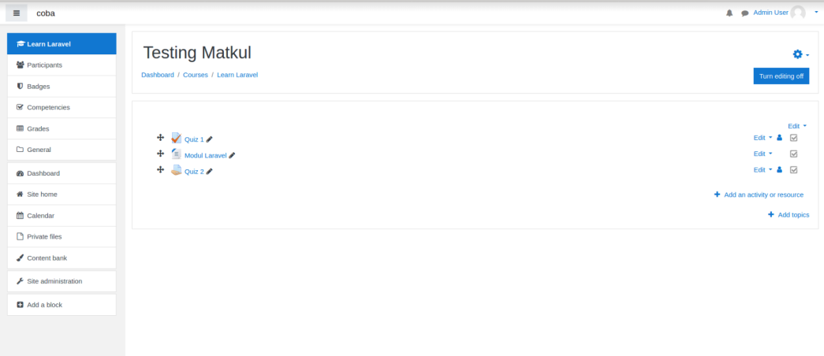

Picture 4.4 Course Moodle Page

1. --num-conns

The num-conns variable is a variable filled with the number of requests that will be made and sent to the server.

1. --rate

Variable rate is a variable filled with the number of requests per second sent to the server.

1. --timeout

The timeout variable is the load time limit required by the web server to complete the web page rendering process sent by the benchmark software. In this study the timeout was configured to be 10 seconds. The figure is 10 seconds because it is adjusted to ITU-T G.1030 11/2005 standard regarding loss of attention time. In ITU-T G.1030 11/2005, it is stated that 10 seconds is the time limit for website users to stay focused waiting for the rendering results from the web server.

* 1. **Test Database Integration between Nodes**

In this study, a database integration test between nodes was carried out on the two container databases that have been created, namely the container database node1 and container database node2. To find out whether the inter-node database is connected or not, access to one of the database containers is required to check the size of wsrep. Wsrep itself will display information in the form of many clustered nodes. The database container can be accessed by command :

“docker exec -it mariadb-galera-0 bash”,

After entering the database container, enter the database with the command "mysql -u root" as shown in picture 4.5.



Picture 4.5 Command to Enter Database Container

It can be seen in Picture 4.5 in the container entry command, "mariadb-galera-0" is the name of the container database node1. When entering the database, fill the password that was created when the container was created.

After entering the database, check the wsrep_cluster_size with the command :

“ show status like ‘wsrep_cluster_size’ ”,

The output of the command can be seen in the picture 4.6.



Picture 4.6 Output Wsrep_Cluster_Size

It can be seen in Picture 4.6, the value of wsrep_cluster_size is in accordance with the number of nodes created, namely 2 nodes. This indicates that the two container databases are connected and integrated.

* 1. **Docker Test**

Benchmarking server performance measurement in this study using the HTPperf utility which is available on Linux. Httperf can be installed using the command :

‘sudo apt-get install -y httperf’

At the testing stage the system will be tested using :

* 800 connections with 50, 80, dan 100 request/second.
* 1000 connections with 50, 80, dan 100 request/second.
* 1200 connections with 50, 80, dan 100 request/second

Testing is done to see the CPU time, reply rate, reply time, and client timeout on the server.

Here are the test results obtained by performing 800, 1000, 1200 requests with 50, 80, and 100 requests / second. Test with 800 requests with 50 requests / second shown in picture 4.7.

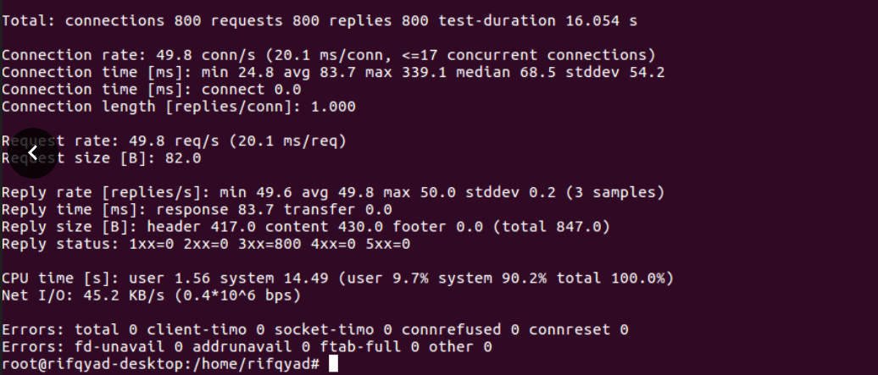

Picture4.7Test docker with HTTPERF with 800 requests and 50 requests/second

In Picture 4.7, the test results of Docker with HTPperf using 800 requests. Tests with 800 requests resulted in a reply rate with an average of 49.8 requests / second, reply time 83.7 ms, CPU time (user) 1.56 seconds, CPU time (system) 14.49 seconds, and the test results also showed the number 0 on the client timeout..

In the next test, it was still carried out with the same number of requests, namely 800 requests, but with a different number of requests / second, namely 80 requests / second. Tests with 800 requests can be done by command :

“httperf --uri = /course/view.php --rate=80 --num-conns=800 --timeout=10”,

Test results on 800 requests with 80 requests / second can be seen in picture 4.8.

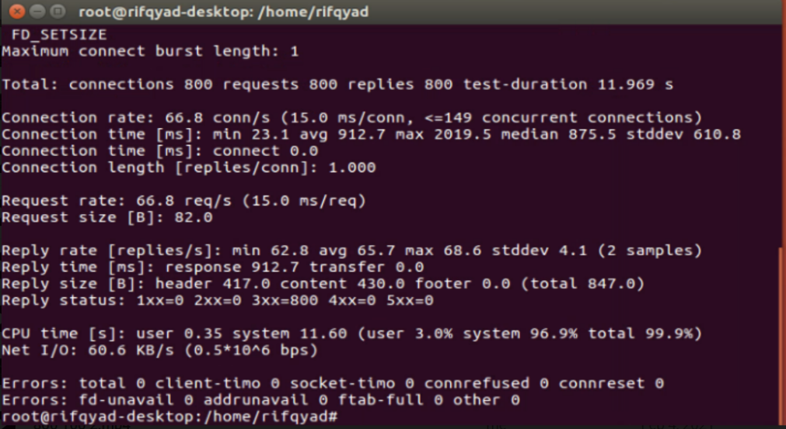

Picture 4.8Test docker with HTTPERF with 800 requests and 80 requests/second

In Picture 4.8, test with 800 requests with 80 requests / second has a reply rate with an average of 65.7 requests / second, reply time is 912.7 ms, CPU time (user) is 0.35 seconds, CPU time (system) is 11.60 seconds, on the results This trial also gets the number 0 on the client timeot.

The last test with a total of 800 requests was carried out with a total of 100 requests / second. 800 requests with a total of 100 requests / second can be done with the command :

“httperf --uri = /course/view.php --rate=100 --num-conns=800 --timeout=10”,

The results of the test with the number of 800 requests and the number of 100 requests / second can be seen in picture 4.9.

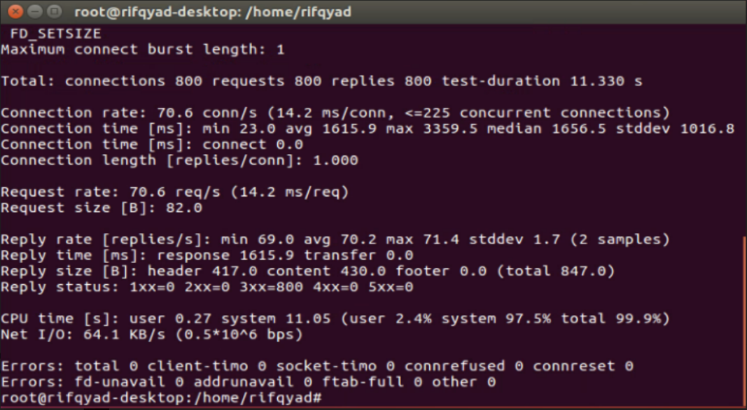

Picture 4.9 Test docker with HTTPERF with 800 requests and 100 requests/second

It can be seen in Picture 4.9, testing 800 requests with a total of 100 requests / second produces a reply rate with an average of 70.2, and the reply time produces 1615.9 ms. It can also be seen that the resulting CPU time (user) is 0.27 seconds and the resulting CPU time (system) is 11.05 seconds. In this test, the result of the client timeout is 0.

The next test was carried out with a different number of requests, namely 1000 requests with a total of 50 requests / second made by command **:**

“httperf --uri = /course/view.php --rate=50 --num-conns=1000 --timeout=10”,

Test results on 1000 requests with 50 requests / second can be seen in the picture 4.10.

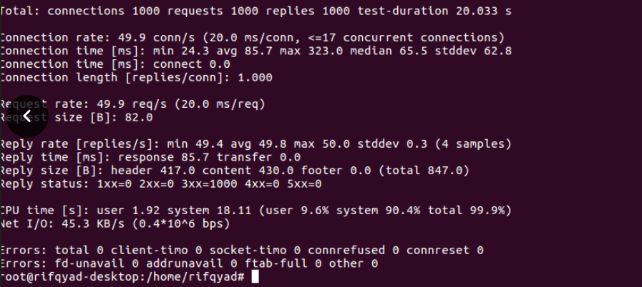

Picture 4.10 Test docker with HTTPERF with 1000 requests and 50 requests/second

In Picture 4.10, the test results of Docker with HTPperf using 1000 requests. Tests with 1000 requests resulted in a reply rate with an average of 49.8 requests / second, reply time 85.7 ms, CPU time (user) 1.92 seconds, CPU time (system) 18.11 seconds, and the test results also showed the number 0 on the client timeout.

The next test was carried out with the same request, namely 1000 requests, but with a different number of requests / second, namely 80 requests / second. This test can be done by command :

“httperf --uri = /course/view.php --rate=80 --num-conns=1000 --timeout=10”,

Tests using 100 requests with 80 requests / second can be seen in the picture 4.11.

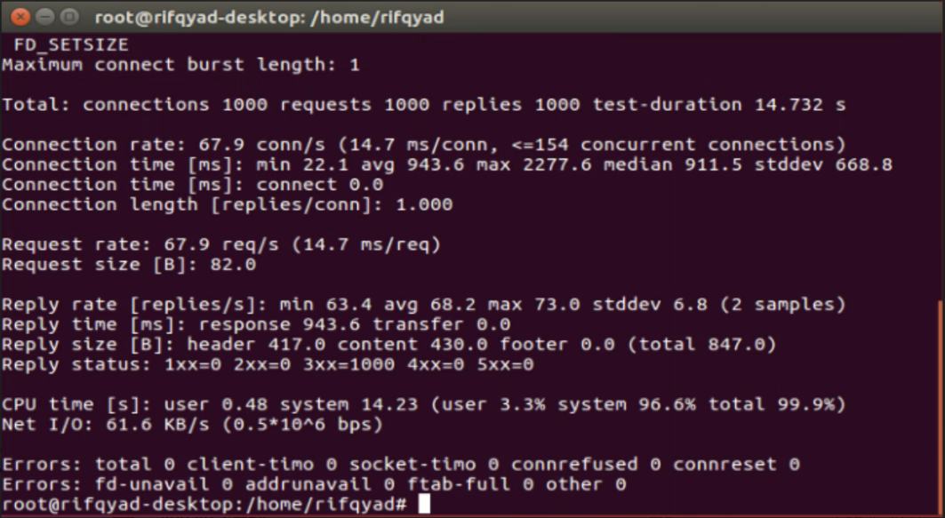

Picture 4.11 Test docker with HTTPERF with 1000 requests and 80 requests/second

In picture 4.11, the results of the trial using 1000 requests with 80 requests / second. In this test, the average reply rate was 68.2 ms, reply time 943.6, CPU time (user) 0.48 and CPU time (system) 14.23. The client timeout in this test also produces the number 0.

The last experiment on the number of 1000 requests is to use 100 requests / second. Experiments can be carried out by command :

“httperf --uri = /course/view.php --rate=100 --num-conns=1000 --timeout=10”,

Experiments using 100 requests with 100 requests / second can be seen in picture 4.12.

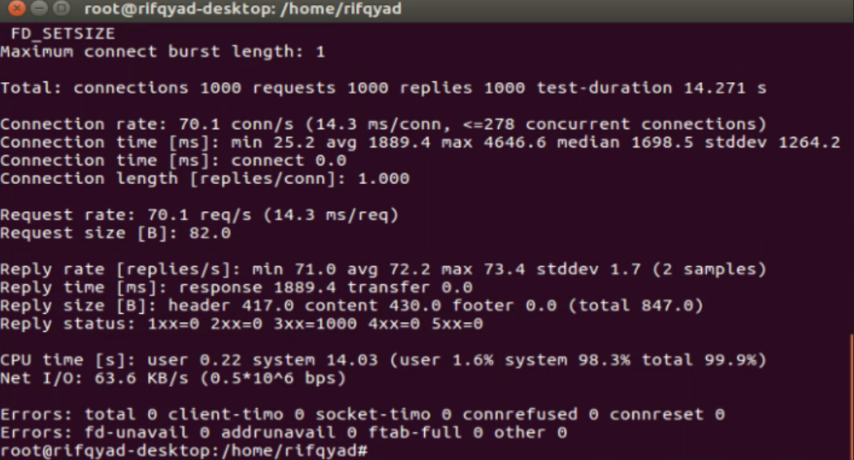

Picture 4.12 Test docker with HTTPERF with 1000 requests and 100 requests/second

In picture 4.12, experiment with 1000 requests with 100 requests / second, the average reply rate is 72.2, the reply time is 1889.4 ms, the CPU time (user) is 0.22 seconds, the CPU time (system) is 14.03 seconds. The client timeout in this experiment also still shows the number 0.

The last experiment was carried out with 1200 requests with 50, 80, 100 requests / second. Experiments of 1200 requests with 50 requests / second can be done by command :

“httperf --uri = /course/view.php --rate=50 --num-conns=1200 --timeout=10”,

Picture 4.13 displays experimental results with 1200 requests.

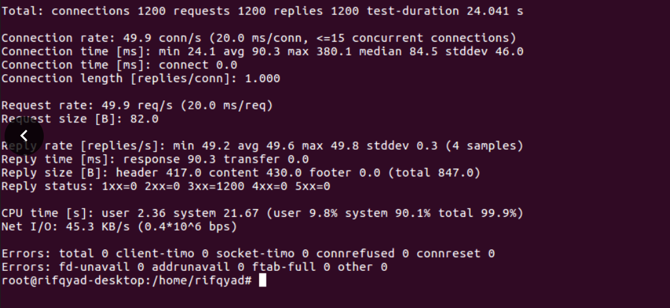

Picture 4.13 Test docker with HTTPERF with 1200 requests and 50 requests/second

In picture 4.13, the test results of Docker with HTPperf using 1200 requests. Experiments with 1200 requests resulted in a reply rate with an average of 49.6 requests / second, reply time of 90.3 ms, CPU time (user) 2.36 seconds, CPU time (system) 21.67 seconds, and the test results also showed the number 0 on the client timeout.

The next experiment was carried out with 1200 requests with 80 requests / second. This experiment can be done by command :

“httperf --uri = /course/view.php --rate=80 --num-conns=1200 --timeout=10”,

The experimental results for 1200 requests with 80 requests / second can be seen in picture 4.14.

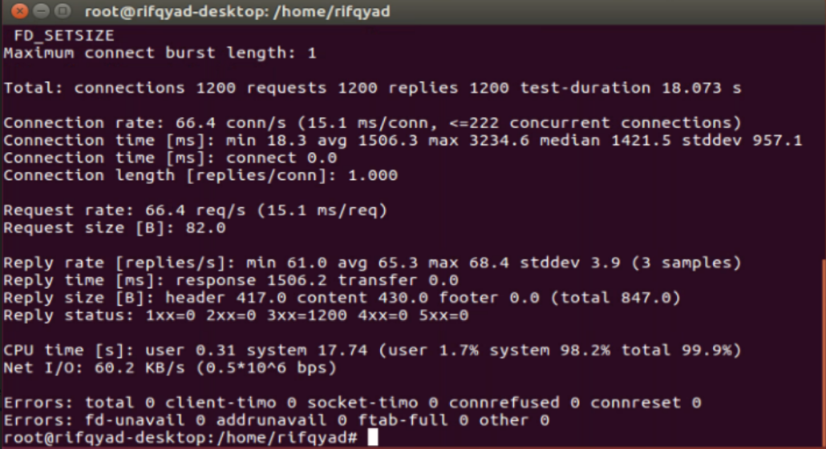

Picture 4.14 Test docker with HTTPERF with 1200 requests and 80 requests/second

In picture 4.14, the results of the experiment with 1200 requests with 80 requests / second. In this experiment, the average reply rate was 65.3 requests / second, reply time was 1506.2 ms, CPU time (user) was 0.31 seconds, CPU time (system) was 17.74 seconds, and client timeout was 0.

The last experiment is with the number of requests 1200 with 100 requests / second can be done by command :

“httperf --uri = /course/view.php --rate=100 --num-conns=1200 --timeout=10”,

The results of the experiment with 1200 requests with 100 requests / second can be seen in picture 4.15.

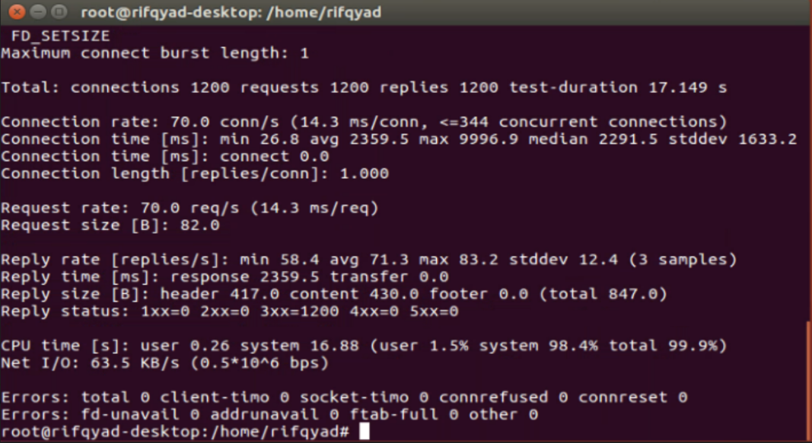

Picture 4.15 Test docker with HTTPERF with 1200 requests and 100 requests/second

It can be seen in picture 4.15 of the results of testing with 1200 requests with 100 requests / second. In this trial, the average reply rate was 71.3, reply time was 2359.5 ms, CPU time (user) was 0.26 seconds, CPU time (system) was 16.88 seconds. The client timeout produces the same number as the previous experiment, namely 0. The test results can be seen in table 4.1.

Table 4.1 Docker Test

| Total Requests | Rate | Reply Rate | Reply Time (ms) | CPU Time (User (s)) | CPU Time (System (s)) | Client TimeOut |
| --- | --- | --- | --- | --- | --- | --- |
| 800 | 50 | 49.8 | 83.7 | 1.56 | 14.49 | 0 |
| 80 | 65.7 | 912.7 | 0.35 | 11.60 | 0 |
| 100 | 70.2 | 1615.9 | 0.27 | 11.05 | 0 |
| 1000 | 50 | 49.8 | 85.7 | 1.92 | 18.11 | 0 |
| 80 | 68.2 | 943.6 | 0.48 | 14.23 | 0 |
| 100 | 72.2 | 1889.4 | 0.22 | 14.03 | 0 |
| 1200 | 50 | 46.9 | 90.3 | 2.36 | 21.67 | 0 |
| 80 | 65.3 | 1506.2 | 0.31 | 17.74 | 0 |
| 100 | 71.3 | 2359.5 | 0.26 | 16.88 | 0 |

* + 1. **Reply Rate**

In the results of three studies with different number of requests, various average reply rates were obtained. Reply rate is the average number of requests returned per second.The result of the reply rate in research with the number of requests for 800 requests, 1000 requests, and 1200 requests with 50, 80, and 100 requests / second can be seen in table 4.2.

Tabel 4.2 Reply Rate Test Result

| Total Requests | Request/second | Reply Rate (avg) |
| --- | --- | --- |
| 800 | 50 | 49.8 |
| 80 | 65.7 |
| 100 | 70.2 |
| 1000 | 50 | 49.8 |
| 80 | 68.2 |
| 100 | 72.2 |
| 1200 | 50 | 46.9 |
| 80 | 65.3 |
| 100 | 71.3 |

It can be seen in table 4.2 that the average server returns requests on a trial 800 requests with 50 requests / second returns an average of 49.8 requests / second, and in trials with the same number of requests with different requests / second, namely 80 requests / second, and 100 requests / second increased the average request to 65.7 requests / second and 70.2 requests / second.

In the 1000 request trial with 50 requests / second, the server using Docker returned the same average as the test results with a total of 800 requests with 50 requests / second, namely 49.8 requests / second. When the request / second is added to 80 requests / second and 100 requests / second, the average server sending requests / second also increases to 68.2 requests / second, and 72.2 requests / second.

Experiments with 1200 requests were also carried out with 3 different numbers of requests / second, namely 50, 80, and 100 requests / second. The test results also provide information that when the number of requests / second is increased, the average server returning requests will increase. In experiments with 50 requests / second the server can return requests with a total of 49.6 requests / second. In the experiment 80 requests / second the server returned requests with an average of 65.3 requests / second, while in the experiment with 100 requests / second the average server returned requests was 71.3 requests / second. It can be concluded that when the number of requests / second is added, the average number of requests returned will also increase.

* + 1. **Reply Time**

In the results of research with different number of requests, various reply times were obtained. Reply time is the average time a request is returned by the server. The results of reply time in milliseconds (ms) in the research with the number of 800 requests, 1000 requests, and 1200 requests with 50 requests / second, 80 requests / second, 100 requests / second can be seen in table 4.3.

Tabel 4.3 Reply Time Test Result

| Total Requests | Request/second | Reply Time (ms) |
| --- | --- | --- |
| 800 | 50 | 83.7 |
| 80 | 912.7 |
| 100 | 1615.9 |
| 1000 | 50 | 85.7 |
| 80 | 943.6 |
| 100 | 1889.4 |
| 1200 | 50 | 90.3 |
| 80 | 1506.2 |
| 100 | 2359.5 |

It can be seen in table 4.3, the reply time carried out by experimenting with 800 requests with 50 requests / second produces 83.7 ms, when the number of requests / second is added to 80 requests / second, the resulting reply time has increased to 912.7 ms, as well as when request / second seconds added to 100 requests / second, reply time has increased again to 1615.9 ms.

In experiments with the number of different requests, namely 1000 requests, it has also increased. In a trial with a total of 1000 requests with 50 requests / second, the resulting reply time was 85.7 ms, then increased to 943.6 ms in the test with 80 requests / second. In an experiment with 100 requests / second the reply time also increased to 1889.4 ms.

The last experiment was carried out with a total of 1200 requests, the reply time also increased. In a trial with a total of 1200 requests with 50 requests / second, the resulting reply time was 90.3 ms, then increased to 1506.2 ms in the test with 80 requests / second. In the experiment using 100 requests / second the reply time has increased again to 2359.5 ms. It can be concluded that the fewer requests and requests / second that are sent to the server, the faster the server returns requests to the client.

* + 1. **CPU Time**

In the results of three studies with different number of requests, various CPU times were obtained. CPU Time is the amount of time the CPU takes to process instructions, and programs. There are two CPU time, namely CPU time user and CPU time system. CPU time is the amount of time the CPU takes to process instructions and programs in user mode, while the CPU system time is the time spent by the CPU to process instructions, programs, and also the operating system in system mode. The results of CPU Time in research with the number of requests 800 requests, 1000 requests and 1200 requests with 50, 80, 100 requests / second can be seen in table 4.4.

Table 4.4 CPU Time Test Result

| Total Requests | Rate | CPU Time  (User (s)) | CPU Time  (System (s)) |
| --- | --- | --- | --- |
| 800 | 50 | 1.56 | 14.49 |
| 80 | 0.35 | 11.60 |
| 100 | 0.27 | 11.05 |
| 1000 | 50 | 1.92 | 18.11 |
| 80 | 0.48 | 14.23 |
| 100 | 0.22 | 14.03 |
| 1200 | 50 | 2.36 | 21.67 |
| 80 | 0.31 | 17.74 |
| 100 | 0.26 | 16.88 |

It can be seen in table 4.4 which was carried out by experimenting with 800 requests with 50 requests / second, the results obtained CPU Time User 1.56 seconds. The results of the experiment using the same number of requests, namely 800 requests with 80 requests / second and 100 requests / second, decreased to 0.35 seconds and 0.27 seconds.

In the experiment with 1000 requests with 50 requests / second, it decreased compared to the experiment at 800 requests with 50 requests / second, to 1.92 seconds, but when the number of requests was added, it became 80 requests / second and 100 requests / second, the user's CPU time increased. to 0.48 seconds and 0.22 seconds.

In the experiment with 1200 requests with 50 requests / second, the CPU time of the user returned decreased compared to the experiment at 1000 requests with 50 requests / second, to 2.36 seconds, but as in the experiment with 1000 requests, the user's CPU time got an increase when the number of requests / seconds plus. When the number of requests / second became 80 requests / second, the user's CPU time was 0.31 seconds, and increased to 0.26 seconds when the number of requests was replaced by 100 requests / second. It can be concluded that on servers that use Docker, when the number of requests / second is increased, the CPU time of the user will be faster. This addition is caused so that the CPU in user mode can process all program instructions given without causing the client to timeout.

In table 4.4, there are the results of CPU Time in system mode. In an experiment with 800 requests with 50 requests / second, the CPU Time System was 14.49 seconds. When the request / second is increased to 80 requests / second, the CPU time system has decreased to 11.60 seconds, likewise when the request / second is increased to 100 requests / second, the CPU time system has decreased to 11.05.

In the trial of 1000 requests with 50 requests / second, it increased to 18.11 seconds compared to experiments on 800 requests with 50 requests / second. When requests / sec are increased to 80 requests / sec, the system CPU time has decreased to 14.23 seconds. The CPU time of the system also decreased to 14.03 seconds when the number of requests / second was increased to 100 requests / second.

In the trial, 1200 requests with 50 requests / second also increased to 21.67 seconds compared to experiments on 1000 requests with 50 requests / second. When the request / second is increased to 80 requests / second, the CPU time of the system has decreased to 17.74 seconds. The CPU time of the system also decreased to 16.68 seconds when the number of requests / second was increased to 100 requests / second. It can be concluded on servers that use docker, that the fewer requests sent to the server, the faster the CPU processes instructions, programs, and the operating system in system mode. In this experiment it can also be concluded that when the number of requests / second is increased, the CPU time system speed will be faster, this is useful to prevent client timeouts.

* + 1. **Client Timeout**

In the results of three studies with different number of requests, the results of the client timeout are the same. Client timeout is the number of services experiencing a timeout on the client side because the server fails to send requests back to the client, the results of the research reply time with the number of requests for 800 requests, 1000 requests and 1200 requests with 50, 80, 100 requests / second can be seen in table 4.5.

Table 4.5 Client TimeOut Test Result

| Total Requests | Rate | Client Timeout |
| --- | --- | --- |
| 800 | 50 | 0 |
| 80 | 0 |
| 100 | 0 |
| 1000 | 50 | 0 |
| 80 | 0 |
| 100 | 0 |
| 1200 | 50 | 0 |
| 80 | 0 |
| 100 | 0 |

It can be seen in table 4.5 The results of the client timeout generated by each request are 0. This indicates that the request returned by the server did not experience a timeout on the client side, which means that the server can return all requests without failing.

* 1. **Virtual Machine Test**

In this study also compared the performance of Docker as a virtualization technique with other virtualization technologies, namely Virtual Machines. In the test results with a virtual machine that was carried out with the same specifications, namely an AMD Ryzen 5 3400G processor, with 8GB RAM and AMD Radeon (TM) GPU RX Vega 11 Graphics, as well as the number of requests sent and requests per second the same, namely 800 requests, 1000 requests, and 1200 requests with 50, 80, 100 requests / second. Experiments with 800 requests with 50 requests / second can be done by command :

“httperf --uri = /course/view.php --rate=50 --num-conns=800 --timeout=10”.

The results of the experiment using a virtual machine with 800 requests and 50 requests / second can be seen in picture 4.16.

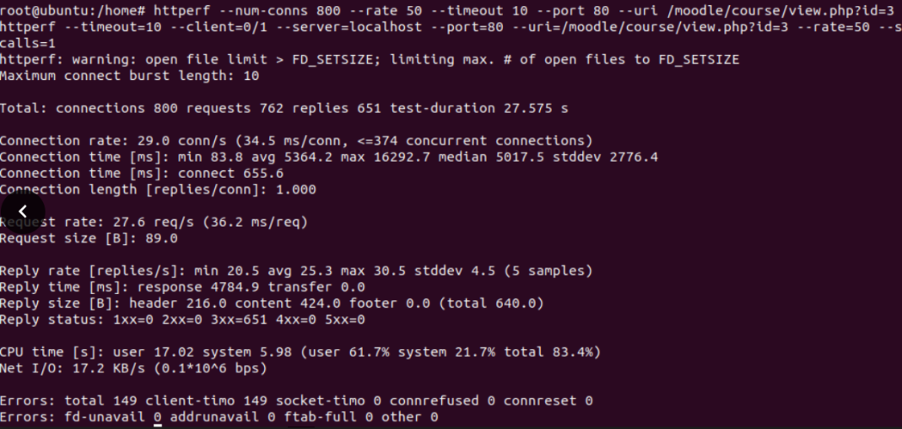

Picture 4.16 Test Virtual Machine with HTTPERF with 800 requests and 50 requests/second

In picture 4.16, test results of Docker with HTPperf using 800 requests. Experiments with 800 requests resulted in a reply rate with an average of 25.3 requests / second, reply time of 4784.9 ms, CPU time (user) 17.02 seconds, CPU time (system) 5.98 seconds, and the test results also showed the number 149 on the client timeout.

In the next experiment, it was still carried out with the same number of requests, namely 800 requests, but with a different number of requests / second, namely 80 requests / second. This experiment can be done by command :

“httperf --uri = /course/view.php --rate=80 --num-conns=800 --timeout=10”,

Experiment results on 800 requests with 80 requests / second can be seen in picture 4.17.

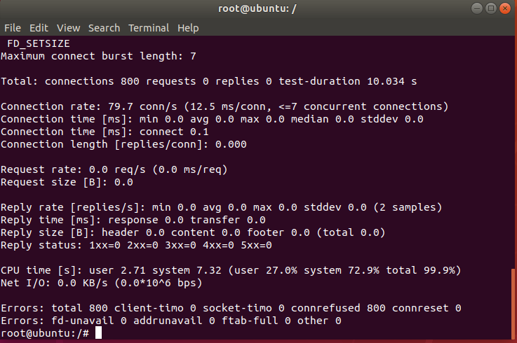

Picture 4.17 Test Virtual Machine with HTTPERF with 800 requests and 80 requests/second

It can be seen in the picture 4.17 reply rate, the resulting reply time is 0. At the CPU time (user) the number is 2.71 seconds, while the CPU time (system) produces the number 7.32 seconds. The client timeout is 800.

The last experiment on the number of 800 requests is to use 100 requests / second. Experiments can be carried out by command :

“httperf --uri = /course/view.php --rate=100 --num-conns=800 --timeout=10”,

Experiment results on 800 requests with 80 requests / second can be seen in picture 4.18.

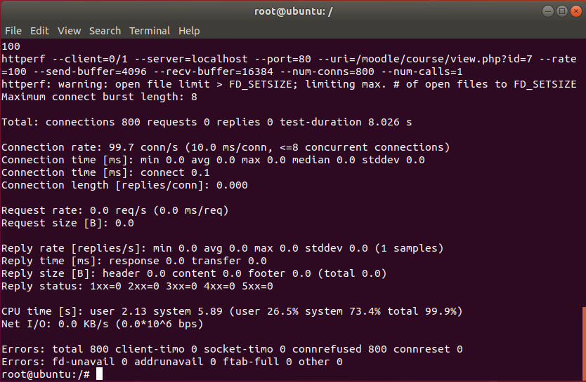

Picture 4.18 Test Virtual Machine with HTTPERF with 800 requests and 100 requests/second

In picture 4.18 reply rate, the resulting reply time is 0. The CPU time (user) is 2.13 seconds, while the CPU time (system) is 5.89 seconds. The client timeout is 800.

The next experiment is done with a different number of requests, namely 1000 requests with 50 requests / second which can be done by command **:**

“httperf --uri = /course/view.php --rate=50 --num-conns=1000 --timeout=10”,

The results of the experiment using a virtual machine with 1000 requests can be seen in picture 4.19.

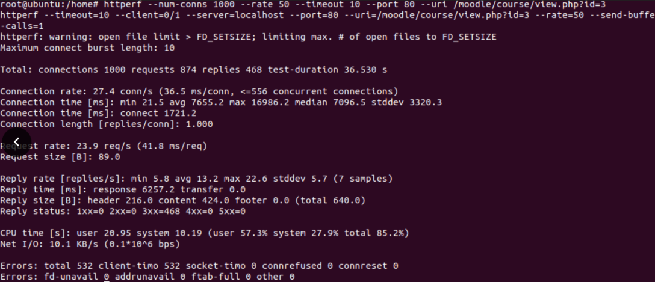

Picture 4.19 Test Virtual Machine with HTTPERF with 1000 requests and 50 requests/second

In picture 4.19, the test results of Docker with HTPperf using 1000 requests with 50 requests / second. This experiment resulted in a reply rate with an average of 13.2 requests / second, reply time of 6257.2 ms, CPU time (user) 20.95 seconds, CPU time (system) 10.19 seconds, and the test results also showed the number 532 on the client timeout.

The next experiment was carried out with 1000 requests with 80 requests / second. Experiments were carried out by command :

“httperf --uri = /course/view.php --rate=80 --num-conns=1000 --timeout=10”,

The experimental results can be seen in the picture 4.20.

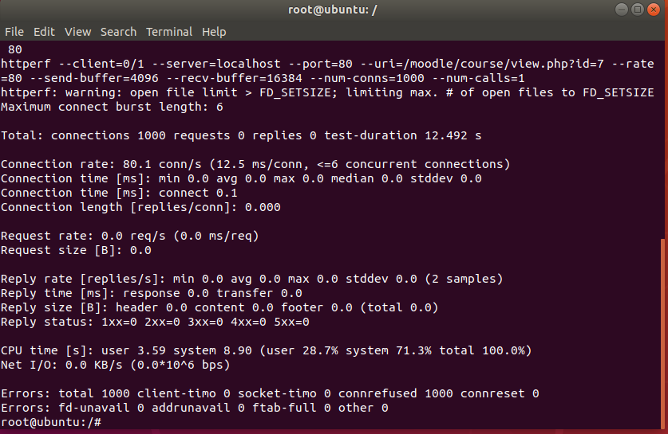

Picture 4.20 Test Virtual Machine with HTTPERF with 1000 requests and 80 requests/second

In picture 4.20 the reply rate, the resulting reply time is 0. At the CPU time (user) the number is 3.59 seconds, while the CPU time (system) produces the number 8.90 seconds. The client timeout is 1000.

The last experiment on the number of 1000 requests was carried out with 100 requests / second. Experiments were carried out by command :

“httperf --uri = /course/view.php --rate=80 --num-conns=1000 --timeout=10”,

The experimental results can be seen in the picture 4.21

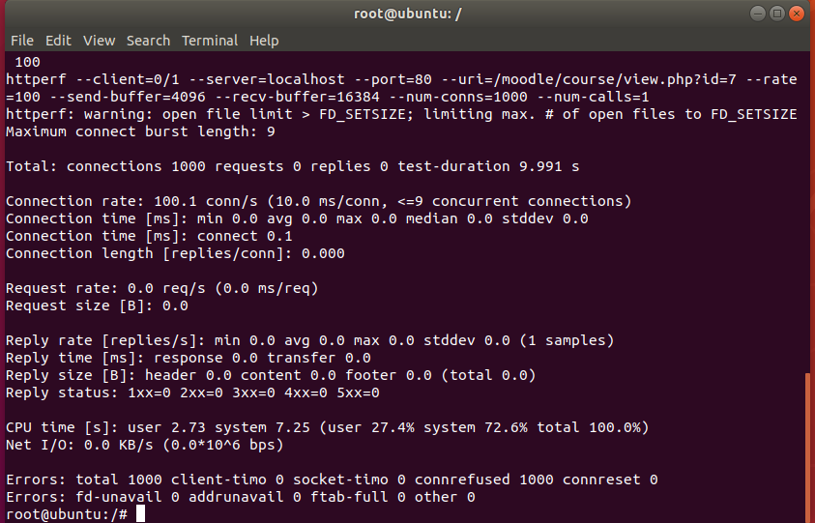

Picture 4.21 Test Virtual Machine with HTTPERF with 1000 requests and 100 requests/second

In picture 4.21 the reply rate, the resulting reply time is 0. In the CPU time (user) the number is 2.73 seconds, while the CPU time (system) is 7.25 seconds. The client timeout is 1000.

The last experiment was carried out with 1200 requests with 50, 80, 100 requests / second. Experiments of 1200 requests with 50 requests / second can be done by command :

“httperf --uri = /course/view.php --rate=50 --num-conns=1200 --timeout=10”,

The results of the experiment using a virtual machine with 1200 requests can be seen in the picture 4.22.

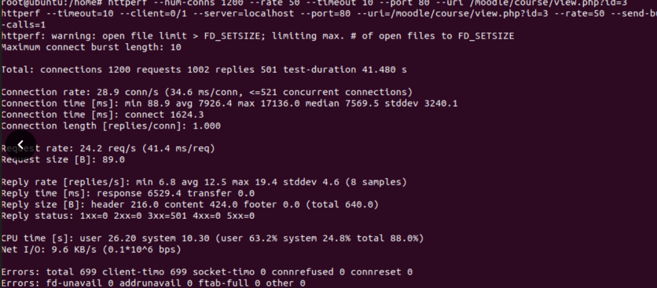

Picture 4.22 Test Virtual Machine with HTTPERF with 1200 requests and 50 requests/second

In picture 4.22, the test results of Docker with HTPperf using 1200 requests. Experiments with 1200 requests resulted in a reply rate with an average of 12.5 requests / second, reply time of 6529.4 ms, CPU time (user) 26.20 seconds, CPU time (system) 10.30 seconds, and the test results also showed the number 699 on the client timeout.

The next experiment was carried out with 1,200 requests with 80 requests / second. This experiment can be done by command :

“httperf --uri = /course/view.php --rate=80 --num-conns=1200 --timeout=10”,

The results of the experiment on 1200 requests with 80 requests / second can be seen in picture 4.23.

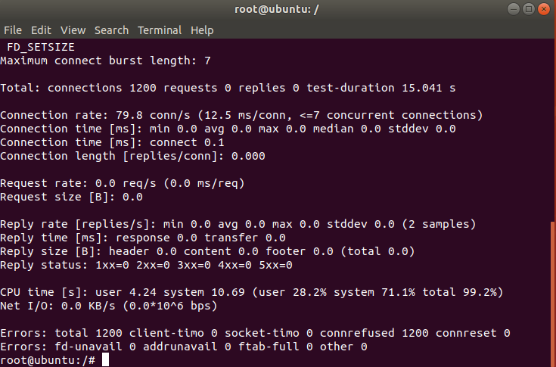

Picture 4.23 Test Virtual Machine with HTTPERF with 1200 requests and 80 requests/second

In picture 4.23 the reply rate, the resulting reply time is 0. In the CPU time (user) the number is 4.24 seconds, while the CPU time (system) is 10.69 seconds. The client timeout is 1200.

The last experiment performed on 1200 requests with 100 requests / second can be performed by command :

“httperf --uri = /course/view.php --rate=100 --num-conns=1200 --timeout=10”,

The experimental results on 1200 requests with 100 requests / second can be seen in picture 4.24.

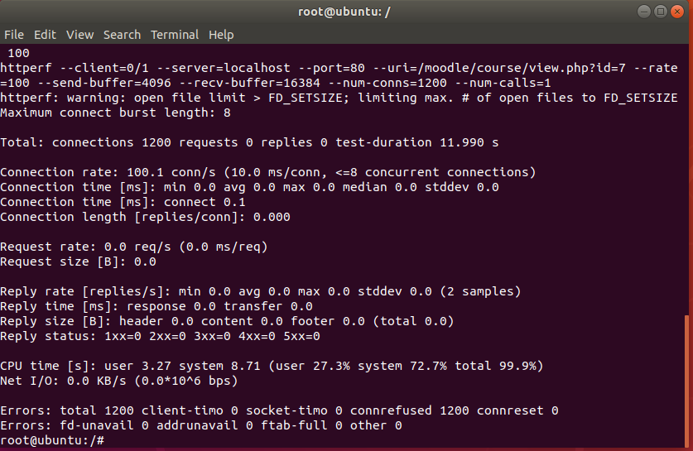

Picture 4.24 Test Virtual Machine with HTTPERF with 1200 requests and 100 requests/second

In picture 4.24 reply rate, the resulting reply time is 0. In the CPU time (user) the number is 3.27 seconds, while the CPU time (system) produces the number 8.71 seconds. The client timeout is 1200.

Comparison of reply rate, reply time, CPU time and client timeout for virtual machines and dockers can be seen in table 4.6.

Table 4.6 Docker and Vritual Machine Comparation

| TeknologiVirtualisasi | Total Request | Rate | Reply Rate | Reply Time (ms) | CPU Time (User (s)) | CPU Time (System (s)) | Client TimeOut |
| --- | --- | --- | --- | --- | --- | --- | --- |
| Docker | 800 | 50 | 49.8 | 83.7 | 1.56 | 14.49 | 0 |
| 80 | 65.7 | 912.7 | 0.35 | 11.60 | 0 |
| 100 | 70.2 | 1615.9 | 0.27 | 11.05 | 0 |
| 1000 | 50 | 49.8 | 85.7 | 1.92 | 18.11 | 0 |
| 80 | 68.2 | 943.6 | 0.48 | 14.23 | 0 |
| 100 | 72.2 | 1889.4 | 0.22 | 14.03 | 0 |
| 1200 | 50 | 46.9 | 90.3 | 2.36 | 21.67 | 0 |
| 80 | 65.3 | 1506.2 | 0.31 | 17.74 | 0 |
| 100 | 71.3 | 2359.5 | 0.26 | 16.88 | 0 |

Table 4.6 Docker and Vritual Machine Comparation

| TeknologiVirtualisasi | Total Request | Rate | Reply Rate | Reply Time (ms) | CPU Time (User (s)) | CPU Time (System (s)) | Client TimeOut |
| --- | --- | --- | --- | --- | --- | --- | --- |
| Virtual Machine | 800 | 50 | 25.3 | 4784 | 17.2 | 5.98 | 149 |
| 80 | 0 | 0 | 2.71 | 7.32 | 800 |
| 100 | 0 | 0 | 2.13 | 5.89 | 800 |
| 1000 | 50 | 13.2 | 6257 | 20.95 | 10.19 | 532 |
| 80 | 0 | 0 | 3.59 | 8.90 | 1000 |
| 100 | 0 | 0 | 2.73 | 7.25 | 1000 |
| 1200 | 50 | 12.5 | 6529 | 26.20 | 10.30 | 699 |
| 80 | 0 | 0 | 4.24 | 10.69 | 1200 |
| 100 | 0 | 0 | 3.27 | 8.71 | 1200 |

It can be seen in table 4.6, in the experiment with the number of 800, 1000, 1200 requests with 50 requests / second, servers that use Docker have a higher reply rate, which means that servers using Docker can reply to more requests in 1 second compared to virtual machines..

In experiments with 800, 1000, 1200 requests with 80 and 100 requests / second, servers using Docker can still return requests without experiencing a client timeout, while virtual machines return 0 requests with the number of client timeouts equal to the number of requests, where this indicates that the server failed to send the request back and that the server is overloaded.

It can also be seen in the trial reply time with a number of 800, 1000, 1200 requests with 50 requests / second, servers that use docker also have a faster time to reverse requests than servers that use virtual machines.

In experiments with a number of 800, 1000, 1200 requests with 80 and 100 requests / second, servers that use Docker have increased quite high, even though Docker managed to send all requests without experiencing a client timeout. In the virtual machine there is an overload so that the reply time shows the number 0.

In the CPU time of user mode with a number of 800, 1000, 1200 requests with 50 requests / second, servers that use docker are superior to virtual machines, which means that docker is faster in processing instructions and programs in user mode. The CPU time of the virtual machine system mode looks superior to the docker because the virtual machine takes up quite a lot of CPU resources, making it faster to process commands, programs, and also the operating system in system mode.

In experiments with the number of 800, 1000, 1200 requests with 80 and 100 requests / second, servers that use docker get the results that user CPU time and system CPU time is faster than 50 requests / second, because the server using Docker manages the resources of its container itself, thus getting a faster CPU time, but this results in an increase in reply time. Even though the virtual machine is overloaded, it still has CPU time users and CPU time systems.

In the number of client timeout servers at Docker experience 0 client timeouts, which means that the server using Docker has successfully returned all existing requests without experiencing a timeout on the client side. On a server that uses a virtual machine in the experiment using 800 requests with 50 requests / second, the server using the virtual machine has a total of 149 client timeouts, which means that when the server sends a request back, 149 clients experience a timeout, while when the number of requests / second is added to 80 and 100 requests / second, the number of client timeouts increases to be the same as the number of requests sent, so it can be concluded that the server failed to send all existing requests and there was an overload. In the 1000 request trial with 50 requests / second, the number of client timeouts increased to 532, and when requests were increased to 80 and 100 requests / second, the server using the virtual machine was also overloaded. In the trial of 1200 requests with 50 requests / second, the server using the virtual machine also experienced 699 client timeouts, while when the number of requests was added to 80 and 100 requests / second, the server was overloaded.

* 1. **Test Server Performance in terms of CPU Usage**

In this study also compared server performance in terms of CPU usage in percent using the help of a stacer application. Picture 4.25 is the CPU usage of the moodle container.

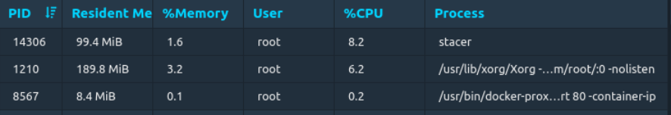

Picture 4.25 CPU Usage on Moodle Container

It can be seen in picture 4.25 container moodle with root user consuming 0.2% CPU resource, and 0.1% memory usage.

CPU usage on two container databases, namely container database node1 and container database node2 can be seen in picture 4.26.

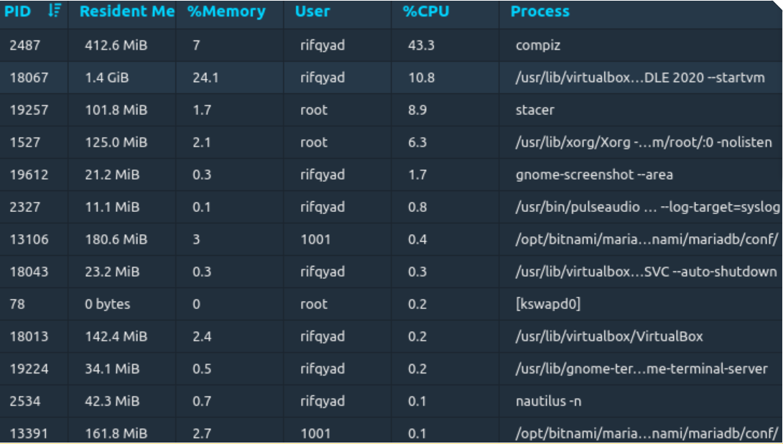

Picture 4.26 CPU Usage on Database Container

It can be seen in picture 4:26 CPU resource usage in node1 database container consumes resources as much as 0.4% and memory usage as much as 3%, while node 2 consumes 0.1% of resources and memory usage is 2.7%.

The CPU usage on VirtualBox running the Moodle VM can be seen in picture 4.27.

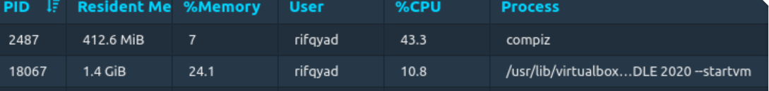

Picture 4.27 CPU Usage on Virtual Box that using for Running Moodle VM

It can be seen in picture 4.27 CPU resource usage for Virtual boxes running Moodle VMs consumes 10.8% of resources and 24.1% of memory usage.

Comparison of Docker and Virtual Machine in terms of CPU usage can be seen in table 4.7.

Table 4.7 Comparison of Docker and Virtual Machine in terms of CPU Usage

| Virtualitation Technology | Service | CPU (%) | Memory (%) |
| --- | --- | --- | --- |
| Docker | Container Moodle | 0.2 | 0.1 |
| Container Database Node 1 | 0.4 | 3 |
| Container Database Node 2 | 0.1 | 2.7 |
| Virtual Machine | VirtualBox yang menjalankan VM Moodle | 10.8 | 24.1 |

In the test results presented in table 4.7, it can be seen that the Docker virtualization technology can return all requests without experiencing a client timeout, while in virtual machines, the server fails to return some existing requests, and it can trigger an overload on the server because it is too lots of requests resulting in client time out. Docker also returns requests much faster than virtual machines. For CPU usage, the moodle container uses 0.2% CPU performance and for each node in the database it uses 0.1% CPU performance, while on a VM that has to run through a virtual box it uses 10.8% CPU performance.

It can be seen in picture 4:26, the use of Docker memory also succeeded in winning over VM where the moodle container used 0.1% of memory and on each container node in the database it used 3% of memory for node 1 and 2.7% on node 2, while in virtual machine using 24.1% memory.

# **CHAPTER V**

# **SUGGESTIONS AND CONCLUSIONS**

* 1. **Conclusion**

Based on the results of research and discussion, the researcher can draw the following conclusions :

1. Implementation of docker on moodle with MariaDB database which is clustered with galera cluster results in better scalability from the use of virtualization techniques that are often used today, namely virtual machines.
2. In comparison to user CPU time, when doing experiments with 800, 1000, 1200 requests with 50 requests / second docker is superior to virtual machines. Docker has a user CPU time of under 3 seconds, while virtual machines have a CPU time of less than 30 seconds, but when the number of requests / second is increased to 80 and 100 requests / second the servers that use virtual machines experience an overload. It can be concluded that in user mode, docker faster to process program instructions compared to virtual machines. In comparison to the CPU time system, when an experiment was carried out with the number of requests 800, 1000, 1200 requests and 50 requests / second, the virtual machine was superior to Docker. Virtual machines have a CPU time system of under 20 seconds, while docker has a CPU time system of under 30 seconds. But after the number of requests / second is increased to 80 and 100 requests / second, the server that uses the virtual machine experiences an overload. It can be concluded that the speed of the virtual machine in processing program instructions and the operating system is faster than the docker. This also causes the virtual machine to take up so much of the existing CPU resource usage.
3. In the reply rate comparison, when experimenting with 800, 1000, and 1200 requests with 50 requests / second Docker had an average reply rate above 49.8 requests / second. When the number of requests is replaced by 80 requests / second, the average reply rate increases, which is above 65.7 requests / second. When the number of requests is increased to 100 requests / second, the average reply rate increases, which is above 70.2 requests / second. Docker can also return all requests without experiencing a client timeout on all existing tests, which means that Docker has successfully returned all requests to the client, while in 800, 1000, and 1200 requests with 50 requests / second the virtual machine has a reply rate far from the number requests that are sent, where the reply rate is the average number of requests returned by the server to the client. This low average causes several requests sent by the client to fail to be returned by the server, resulting in a client timeout. In experiments with 800, 1000, and 1200 requests and the number of requests / second more than 50 requests / second, servers that use virtual machines experience overload.
4. In the results of the benchmarking test using the HTTperf linux utility with 800, 1000, and 1200 requests with 50, 80, 100 requests / second, the implementation of docker on moodle with the MariaDB database clustered with the galera cluster has a reply time of less than 3000 ms, where meaning docker can return 1 request in less than 3000 ms. In experiments with 800, 1000, 1200 with 50 requests / second, servers that use virtual machines have a longer reply time than servers using Docker, namely, more than 4783 ms, which means that the server returns 1 request with a time of more than 4783 ms. In experiments with the number of requests 800, 1000, and 1200 and the number of requests / second more than 50 requests / second the virtual machine is overloaded
5. In the client timeout comparison, Docker managed to return all requests so that there was no client timeout, while in the virtual machine there was a client timeout because the server failed to return several requests, causing an overload on the server.
6. On CPU and memory usage, docker and its containers use less resources on the server. Containers from Moodle use 0.2% of CPU resources and 0.1% memory, while for 2 database containers use 0.1% in each container with 3% memory usage at node 1 and 2.7% memory on node 2.In virtual machines CPU usage uses 10.8% CPU performance with 24.1% memory usage.
   1. **Suggestion**

Based on the conclusions and findings of the research that has been done, some developments that can be done are as follows :

1. Using more than two database nodes to support high availability (High Availability) of a system.
2. Using multiple servers with higher specifications that act as servers of Moodle and more than two database nodes and managing the container with the container manager.
3. Analyze CPU time, reply rate, reply time and client timeout using another Linux utility (Apache Benchmark).
4. Doing trials until the number of requests reaches 5000 or more so that you can see the effect of using Docker more comprehensively.
5. Perform trials with higher variants of ubuntu (ubuntu 18.0.4 and ubuntu 20.0.4).
6. Test Docker with Virtual Private Network

# **BIBLIOGRAPHY**

**Judul dituliskan dalam tanda “” atau dibuat *italic***

**Tambahkan literatur dari buku dan jurnal**

1. Arafat, Aulia., Gani, Taufiq A., Melinda. 2015. Analisis Kinerja MySQL Cluster Menggunakan Metode Load Balancing. Jurnal Rekayasa Elektrika. 11(4), 129-134. DOI: 10.17529/jre.v11i4.2358. **Penerbit Jurnal.**
2. Azizah, Nurul. 2020. Keuntungan Menggunakan Teknologi Learning Management System (LMS). <https://ispringindonesia.com/keuntungan-menggunakan-teknologi-learning-management-system-lms/>. Accessed November 2020

1. Bootupacademyai. 2019. Linux Adalah? Mengenal Sejarah dan Kelebihannya Lengkap!. <https://bootup.ai/blog/linux-adalah/>. Accessed November 2020
2. Bootupacademyai. 2019. Pengertian Database Beserta Fungsi dan Manfaat Penggunaannya. <https://bootup.ai/blog/pengertian-database-beserta-fungsi-dan-manfaat-penggunaannya/>. Accessed November 2020
3. Anonim. 2020. 8 Fitur Penting yang Harus Ada di Learning Management System. [https://www.datanusantara.com/fitur-penting-learning-management-system](https://www.datanusantara.com/fitur-penting-learning-management-system/TanpaPenulis)/. Accessed November 2020
4. Anonim. 2020. Berkenalan dengan Ubuntu. <https://www.dewaweb.com/blog/berkenalan-dengan-ubuntu/>. Accessed November 2020
5. Anonim. 2020. High Availability: Tujuan, Cara Kerja, dan Komponennya. [https://www.dewaweb.com/blog/high-availability-tujuan-cara-kerja/](https://www.dewaweb.com/blog/high-availability-tujuan-cara-kerja/TanpaPenulis). Accessed November 2020
6. Erika. 2020. Github. [https://github.com/httperf/httperf. Accessed November 2020](https://github.com/httperf/httperf.%20Diakses%20November%202020)
7. Fiandrianto, A., 2015, Analisis dan Perbandingan Load Balancer Database HAProxy dan Maxscale dalam Performa Kecepatan Website E-Learning Moodle, Skripsi, Fakultas Teknik, Universitas Negeri Yogyakarta.
8. Kasih, Ayunda Pininta. 2020. Covid-19, Ini Sederet Perubahan Kebijakan Pendidikan di Indonesia. <https://www.bantennews.co.id/dampak-pandemik-covid-19-terhadap-dunia-pendidikan-di-indonesia/>. Accessed November 2020
9. Kurniawan, Suryadi. 2020. Apa Itu Moodle? Panduan Lengkap untuk Pemula. <https://www.niagahoster.co.id/blog/moodle-adalah/>. Accessed November 2020
10. Anonim. 2019. Kelebihan dan Kekurangan Linux dibanding Windows yang Wajib Diketahui. [https://www.liputan6.com/tekno/read/3877666/kelebihan-dan-kekurangan-linux-dibanding-windows-yang-wajib-diketahui/](https://www.liputan6.com/tekno/read/3877666/kelebihan-dan-kekurangan-linux-dibanding-windows-yang-wajib-diketahui/TanpaPenulis). Accessed November 2020
11. Nugroho, Andy. 2020. Mengenal Moodle, Platform Open Source Untuk Pembelajaran. <https://qwords.com/blog/moodle-adalah/>. Accessed November 2020
12. Anonim. 2017. Pengertian Linux Dan Contohnya Secara Singkat. [http://www.pengertianku.net/2017/08/pengertian-linux-dan-contohnya.html/](http://www.pengertianku.net/2017/08/pengertian-linux-dan-contohnya.html/TanpaPenulis). Accessed November 2020
13. Rahmah, Nabila. 2020. Dampak Pandemik Covid-19 Terhadap Dunia Pendidikan di Indonesia. <https://www.bantennews.co.id/dampak-pandemik-covid-19-terhadap-dunia-pendidikan-di-indonesia/>. Accessed November 2020
14. Rizqwati, Diah., Suryanto, Septya A., Syaifuddin. 2018. Pengembangan Mekanisme Akses E-learning Berbasis Linux Container. Jurnal Ilmiah Penelitian dan Pembelajaran Informatika. 3(1), 45-52. **Penerbit Jurnal.**
15. Anonim. 2015. 12 Tipe Dan Pengertian Database Menurut Para Ahli. [https://www.seputarpengetahuan.co.id/2015/02/12-tipe-dan-pengertian-database-menurut-para-ahli.html/](https://www.seputarpengetahuan.co.id/2015/02/12-tipe-dan-pengertian-database-menurut-para-ahli.html/TanpaPenulis). Accessed November 2020
16. Sneddon, Joey. 2020. Ubuntu 16.04 LTS Released, This Is What’s New. <https://www.omgubuntu.co.uk/2016/04/ubuntu-16-04-download-new-features>. Accessed November 2020
17. Anonim. 2020. Pengertian Database. <https://www.termasmedia.com/lainnya/software/69-pengertian-database.html/>. Accessed November 2020
18. Waluyo, Catur Budi. 2020. Kelebihan dan kekurangan Virtualisasi beserta jenis-jenisnya. <https://www.calesmart.com/artikel/Kelebihan-dan-kekurangan-Virtualisasi-beserta-jenis-jenisnya.html>. Accessed November 2020
19. Yasin. 2018. Docker Tutorial: Pengenalan Awal & Instalasi., dari <https://www.niagahoster.co.id/blog/docker-tutorial/>. Accessed November 2020

**Program List Attachment**

* + - 1. **Network Moodle**

docker network create moodle

* + - 1. **Container Moodle**

docker run -d --name moodle_service --network moodle -d -p 80:80 prasta/moodle:latest

* + - 1. **Container Database Node 1**

“docker run -d --name mariadb-galera-0 \

-e MARIADB_GALERA_CLUSTER_NAME=galeracluster \

-e MARIADB_GALERA_MARIABACKUP_USER=galerauserbackup \

-e MARIADB_ROOT_PASSWORD=rifqyadli123 \

-e MARIADB_USER=rifqy \

-e MARIADB_PASSWORD=rifqyadli123 \

-e MARIADB_DATABASE=database_rifqy \

-e MARIADB_REPLICATION_USER=my_replication_user \

-e MARIADB_REPLICATION_PASSWORD=my_replication_password \

bitnami/mariadb-galera:latest”.

* + - 1. **Container Database Node 2**

“docker run -d --name mariadb-galera-1\

-e MARIADB_GALERA_CLUSTER_NAME=galeracluster \ -e MARIADB_GALERA_CLUSTER_ADDRESS = gcomm://mariadb-galera:4657, 0.0.0.0:4567\

-e MARIADB_GALERA_MARIABACKUP_USER=galerauserbackup \

-e MARIADB_ROOT_PASSWORD=rifqyadli123 \

-e MARIADB_USER=rifqy \

-e MARIADB_PASSWORD=rifqyadli123 \

-e MARIADB_DATABASE=database_rifqy \

-e MARIADB_REPLICATION_USER=my_replication_user \

-e MARIADB_REPLICATION_PASSWORD=my_replication_password \

bitnami/mariadb-galera:latest”

* + - 1. **Test with 800 request, 50 request/second**

httperf --uri = /course/view.php?id=3 --rate=50 --num-conns=800 --timeout=10

1. **Test with 800 request, 80 request/second**

httperf --uri = /course/view.php?id=3 --rate=80 --num-conns=800 --timeout=10

1. **Test with 800 request, 100 request/second**

httperf --uri = /course/view.php?id=3 --rate=100 --num-conns=800 --timeout=10

1. **Test with 1000 request, 50 request/second**

httperf --uri = /course/view.php?id=3 --rate=50 --num-conns=1000 --timeout=10

1. **Test with 1000 request, 80 request/second**

httperf --uri = /course/view.php?id=3 --rate=80 --num-conns=1000 --timeout=10

1. **Test with 1000 request, 100 request/second**

httperf --uri = /course/view.php?id=3 --rate=100 --num-conns=1000 --timeout=10

1. **Test 1200 with request, 50 request/second**

httperf --uri = /course/view.php?id=3 --rate=50 --num-conns=1200 --timeout=10

1. **Test 12000 with request, 80 request/second**

httperf --uri = /course/view.php?id=3 --rate=80 --num-conns=1200 --timeout=10

1. **Test 1200 with request, 100 request/second**

httperf --uri = /course/view.php?id=3 --rate=100 --num-conns=1200 --timeout=10

**Output List Attachment**

1. **Output Test Docker with 800 request, 50 request/second**



1. **Output Test Docker with 800 request, 80 request/second**

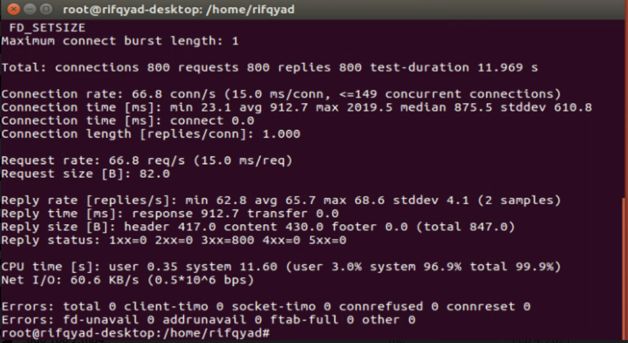

1. **Output Test Docker with 800 request, 100 request/second**

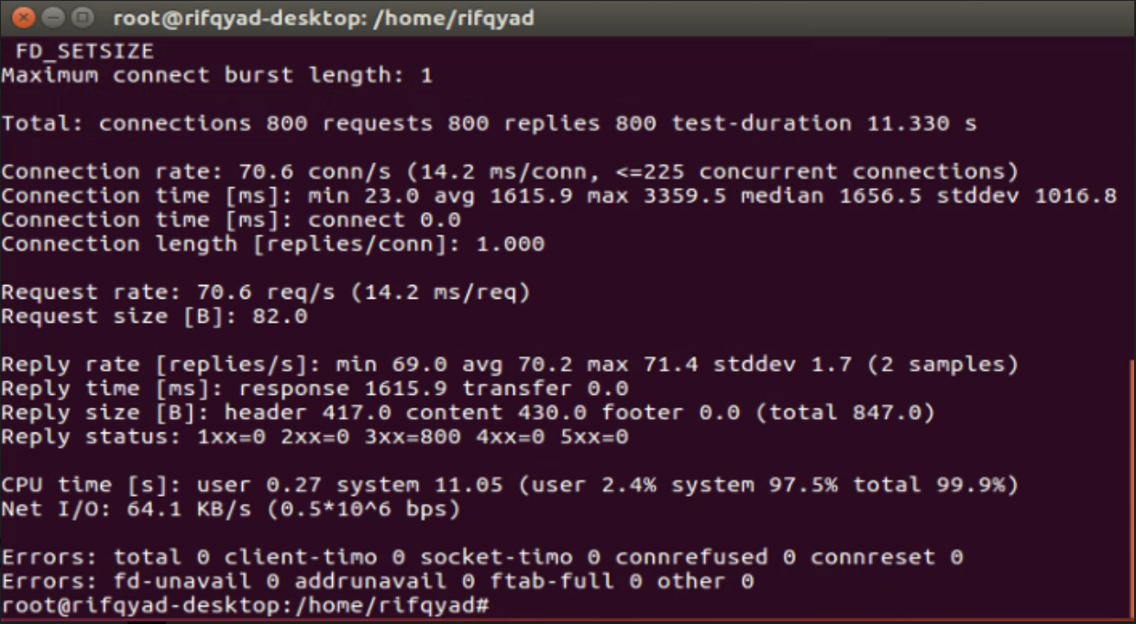

1. **Output Test Docker with 1000 request, 50 request/second**



1. **Output Test Docker with 1000 request, 80 request/second**

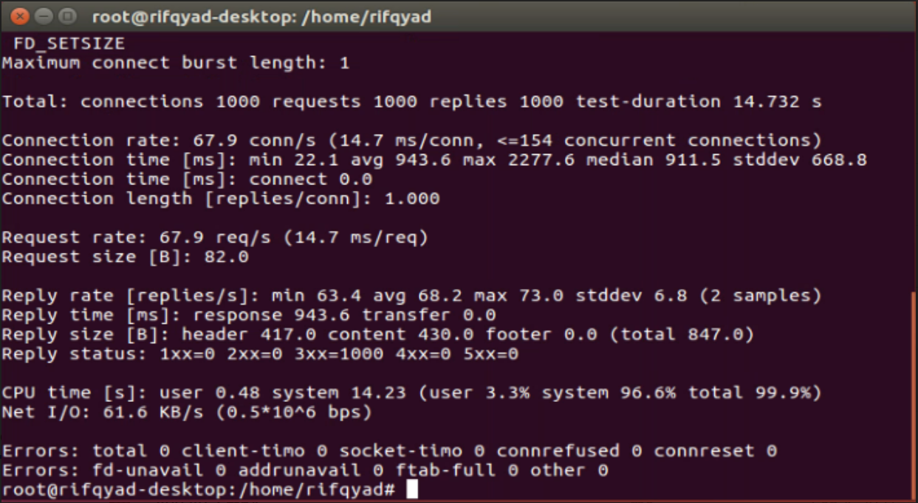

1. **Output Test Docker with 1000 request, 100 request/second**

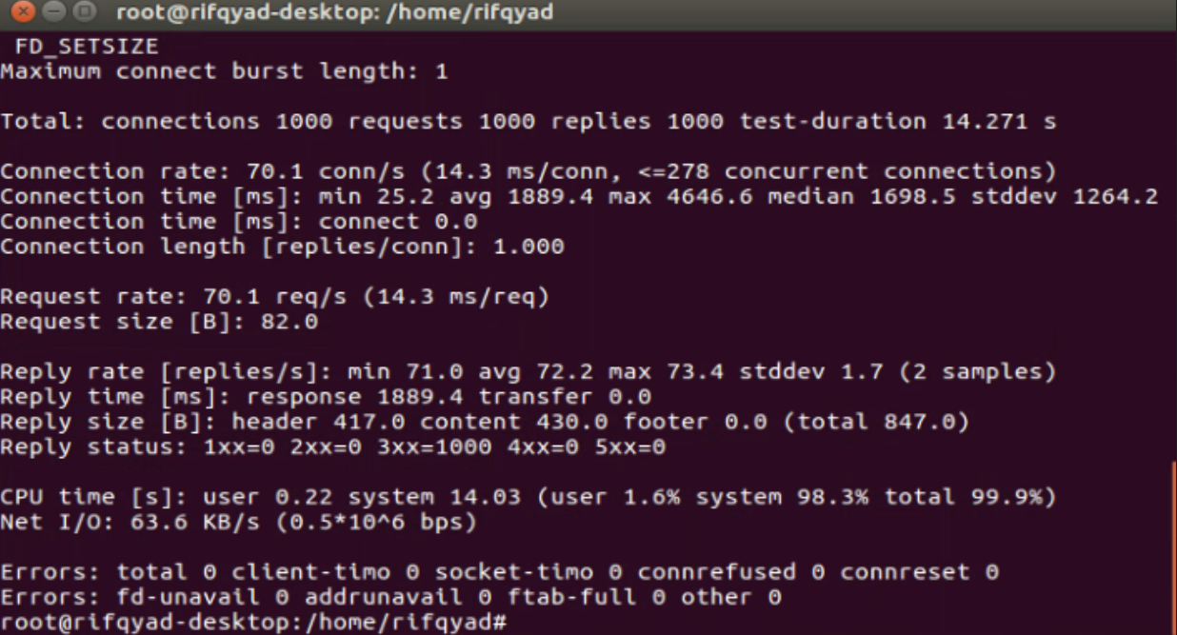

1. **Output Test Docker with 1200 request, 50 request/second**



1. **Output Test Docker with 1200 request, 80 request/second**

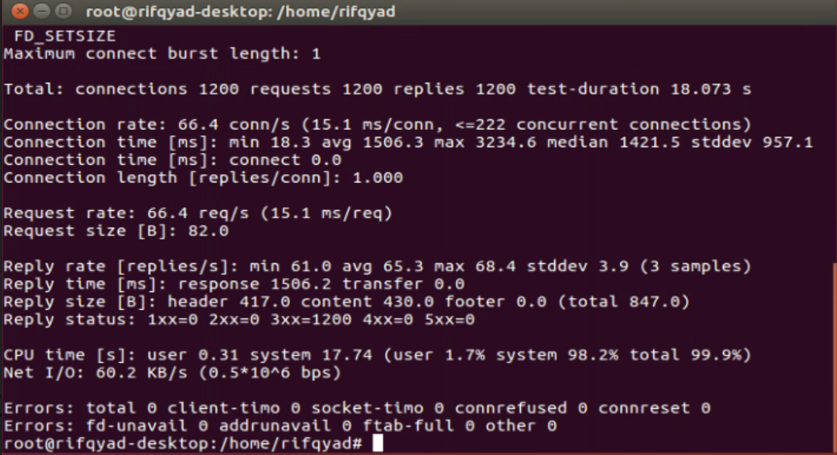

1. **Output Test Docker with 1200 request, 100 request/second**

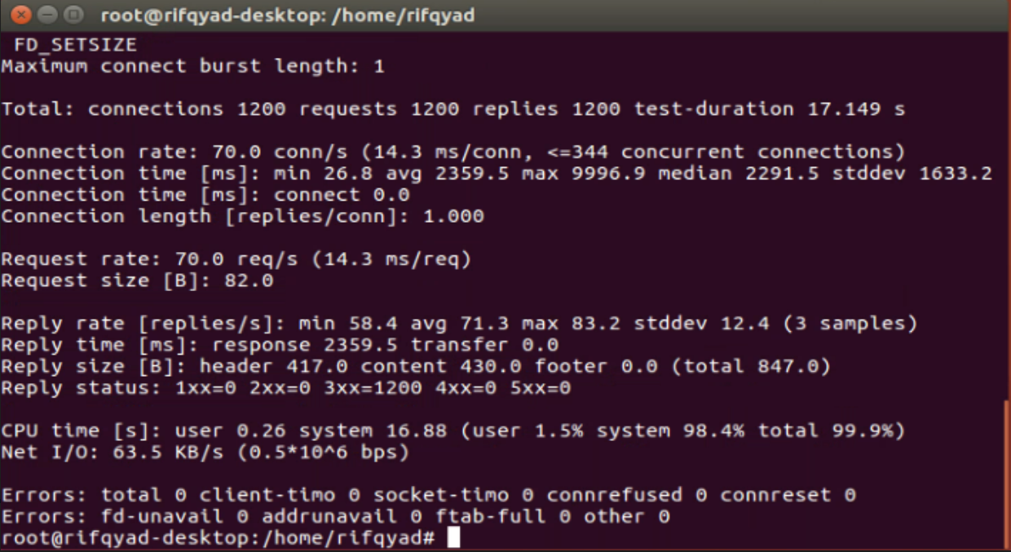

1. **Output Test Virtual Machine with 800 request, 50 request/second**



1. **Output Test Virtual Machine with 800 request, 80 request/second**



1. **Output Test Virtual Machine with 800 request, 100 request/second**



1. **Output Test Virtual Machine with 1000 request, 50 request/second**



1. **Output Test Virtual Machine with 1000 request, 80 request/second**



1. **Output Test Virtual Machine with 1000 request, 100 request/second**



1. **Output Test Virtual Machine with 1200 request, 50 request/second**



1. **Output Test Virtual Machine with 1200 request, 80 request/second**



1. **Output Test Virtual Machine with 1200 request, 100 request/second**

